### Residential

**Class A Buildings - One Family Dwellings: OneFamilyDwellings**

* [A0 Cape Cod](https://www.propertyshark.com/info/class-buildings-one-family-dwellings/#a0)
* [A1 Two Stories Detached (Small or Moderate Size, With or Without Attic)](https://www.propertyshark.com/info/class-buildings-one-family-dwellings/#a1)
* [A2 One Story (Permanent Living Quarters)](https://www.propertyshark.com/info/class-buildings-one-family-dwellings/#a2)
* [A3 Large Suburban Residence](https://www.propertyshark.com/info/class-buildings-one-family-dwellings/#a3)
* [A4 City Residence](https://www.propertyshark.com/info/class-buildings-one-family-dwellings/#a4)
* [A5 Attached or Semi-Detached](https://www.propertyshark.com/info/class-buildings-one-family-dwellings/#a5)
* [A6 Summer Cottages/Mobile Homes/Trailers](https://www.propertyshark.com/info/class-buildings-one-family-dwellings/#a6)
* [A7 Mansion Type](https://www.propertyshark.com/info/class-buildings-one-family-dwellings/#a7)
* [A8 Bungalow Colony/Land Coop Owned](https://www.propertyshark.com/info/class-buildings-one-family-dwellings/#a8)
* [A9 Miscellaneous (Old Buildings, Attached & Semi-Detached Frame Houses, etc.)](https://www.propertyshark.com/info/class-buildings-one-family-dwellings/#a9)

**Class B Buildings - Two Family Dwellings: TwoFamilyDwellings**

* [B1 Brick](https://www.propertyshark.com/info/class-b-buildings-two-family-dwellings/#b1)
* [B2 Frame](https://www.propertyshark.com/info/class-b-buildings-two-family-dwellings/#b2)
* [B3 Converted (From One Family)](https://www.propertyshark.com/info/class-b-buildings-two-family-dwellings/#b3)
* [B9 Miscellaneous (City Type, Old, etc.)](https://www.propertyshark.com/info/class-b-buildings-two-family-dwellings/#b9)

**Class C Buildings - Walk Up Apartments: WalkupApartments**

* [C0 Three Families](https://www.propertyshark.com/info/class-c-buildings-walk-apartments/#c0)
* [C1 Over Six Families Without Stores](https://www.propertyshark.com/info/class-c-buildings-walk-apartments/#c1)
* [C2 Five to Six Families](https://www.propertyshark.com/info/class-c-buildings-walk-apartments/#c2)
* [C3 Four Families](https://www.propertyshark.com/info/class-c-buildings-walk-apartments/#c3)
* [C4 Old Law Tenements](https://www.propertyshark.com/info/class-c-buildings-walk-apartments/#c4)
* [C5 Converted Dwelling or Rooming House](https://www.propertyshark.com/info/class-c-buildings-walk-apartments/#c5)
* [C6 Cooperative (Other Than Condominiums)](https://www.propertyshark.com/info/class-c-buildings-walk-apartments/#c6)
* [C7 Over Six Families With Stores](https://www.propertyshark.com/info/class-c-buildings-walk-apartments/#c7)
* [C8 Co-op Conversion From Loft/Warehouse](https://www.propertyshark.com/info/class-c-buildings-walk-apartments/#c8)
* [C9 Garden Apartments/Mobile Home Park/Trailer Park](https://www.propertyshark.com/info/class-c-buildings-walk-apartments/#c9)

**Class D Buildings - Elevator Apartments: ElevatorApartments**

* [D0 Co-op Conversion From Loft/Warehouse](https://www.propertyshark.com/info/class-d-buildings-elevator-apartments/#d0)
* [D1 Semi-fireproof (Without Stores)](https://www.propertyshark.com/info/class-d-buildings-elevator-apartments/#d1)
* [D2 Artists in Residence](https://www.propertyshark.com/info/class-d-buildings-elevator-apartments/#d2)
* [D3 Fireproof (Standard Construction Without Stores)](https://www.propertyshark.com/info/class-d-buildings-elevator-apartments/#d3)
* [D4 Cooperatives (Other Than Condominiums)](https://www.propertyshark.com/info/class-d-buildings-elevator-apartments/#d4)
* [D5 Converted](https://www.propertyshark.com/info/class-d-buildings-elevator-apartments/#d5)
* [D6 Fireproof - With Stores](https://www.propertyshark.com/info/class-d-buildings-elevator-apartments/#d6)
* [D7 Semi-Fireproof With Stores](https://www.propertyshark.com/info/class-d-buildings-elevator-apartments/#d7)
* [D8 Luxury Type](https://www.propertyshark.com/info/class-d-buildings-elevator-apartments/#d8)
* [D9 Miscellaneous](https://www.propertyshark.com/info/class-d-buildings-elevator-apartments/#d9)

**Class R Buildings – Condominiums: Condominiums**

* [R0 Condo Billing Lot](https://www.propertyshark.com/info/class-r-buildings-condominiums/#r0)
* [R1 2-10 Unit Residential Bldg, Residential Unit](https://www.propertyshark.com/info/class-r-buildings-condominiums/#r1)
* [R2 Walk-up, Residential Unit](https://www.propertyshark.com/info/class-r-buildings-condominiums/#r2)
* [R3 1-3 Story, Residential Unit](https://www.propertyshark.com/info/class-r-buildings-condominiums/#r3)
* [R4 Apartment/Elevated, Residential Unit](https://www.propertyshark.com/info/class-r-buildings-condominiums/#r4)
* [R5 Commercial Unit](https://www.propertyshark.com/info/class-r-buildings-condominiums/#r5)
* [R6 1-3 Units, Residential Unit](https://www.propertyshark.com/info/class-r-buildings-condominiums/#r6)
* [R7 1-3 Units, Commercial Unit](https://www.propertyshark.com/info/class-r-buildings-condominiums/#r7)
* [R8 2-10 Unit Residential Bldg, Commercial Unit](https://www.propertyshark.com/info/class-r-buildings-condominiums/#r8)
* [R9 Condop](https://www.propertyshark.com/info/class-r-buildings-condominiums/#r9)
* [RA Cultural, Medical, Educational, Etc.](https://www.propertyshark.com/info/class-r-buildings-condominiums/#ra)
* [RB Office Space](https://www.propertyshark.com/info/class-r-buildings-condominiums/#rb)
* [RC Commercial Building (Mixed Commercial Condo Building)](https://www.propertyshark.com/info/class-r-buildings-condominiums/#rc)
* [RG Indoor Parking](https://www.propertyshark.com/info/class-r-buildings-condominiums/#rd)
* [RH Hotel/Boatel](https://www.propertyshark.com/info/class-r-buildings-condominiums/#re)
* [RK Retail Space](https://www.propertyshark.com/info/class-r-buildings-condominiums/#rf)
* [RM Mixed Residential & Commercial Building (Mixed Residential & Commercial Condo Building)](https://www.propertyshark.com/info/class-r-buildings-condominiums/#rm)
* [RP Outdoor Parking](https://www.propertyshark.com/info/class-r-buildings-condominiums/#rp)
* [RS Non-Business Storage Space](https://www.propertyshark.com/info/class-r-buildings-condominiums/#rs)
* [RT Terraces/Gardens/Cabanas](https://www.propertyshark.com/info/class-r-buildings-condominiums/#rt)
* [RW Warehouse/Factory/Industrial](https://www.propertyshark.com/info/class-r-buildings-condominiums/#rw)
* [RD Residential Building (Mixed Residential Condo Building)](https://www.propertyshark.com/info/class-r-buildings-condominiums/#rd)
* [RI Mixed Warehouse/Factory/Industrial & Commercial](https://www.propertyshark.com/info/class-r-buildings-condominiums/#ri)
* [RX Mixed Residential & Commercial Building](https://www.propertyshark.com/info/class-r-buildings-condominiums/#rx)

### Mixed Use

**Class S Buildings - Residence - Multiple Use**

* [S0 Primarily One Family with Two Stores or Offices](https://www.propertyshark.com/info/class-s-buildings-residence-multiple-use/#s0)
* [S1 Primarily One Family With Store or Office](https://www.propertyshark.com/info/class-s-buildings-residence-multiple-use/#s1)
* [S2 Primarily Two Family With Store or Office](https://www.propertyshark.com/info/class-s-buildings-residence-multiple-use/#s2)
* [S3 Primarily Three Family With Store or Office](https://www.propertyshark.com/info/class-s-buildings-residence-multiple-use/#s3)
* [S4 Primarily Four Family With Store or Office](https://www.propertyshark.com/info/class-s-buildings-residence-multiple-use/#s4)
* [S5 Primarily Five to Six Family With Store or Office](https://www.propertyshark.com/info/class-s-buildings-residence-multiple-use/#s5)
* [S9 Primarily One to Six Families with Stores or Offices](https://www.propertyshark.com/info/class-s-buildings-residence-multiple-use/#s9)

### Commercial Buildings

**Class H Buildings - Hotels**

* [H1 Luxury Type - Built Prior to 1960](https://www.propertyshark.com/info/class-h-buildings-hotels/#h1)
* [H2 Luxury Type - Built After 1960](https://www.propertyshark.com/info/class-h-buildings-hotels/#h2)
* [H3 Transient Occupancy-Midtown Mn Area](https://www.propertyshark.com/info/class-h-buildings-hotels/#h3)
* [H4 Motels](https://www.propertyshark.com/info/class-h-buildings-hotels/#h4)
* [H5 Private Club, Luxury Type](https://www.propertyshark.com/info/class-h-buildings-hotels/#h5)
* [H6 Apartment Hotels](https://www.propertyshark.com/info/class-h-buildings-hotels/#h6)
* [H7 Apartment Hotels-Co-op Owned](https://www.propertyshark.com/info/class-h-buildings-hotels/#h7)
* [H8 Dormitories](https://www.propertyshark.com/info/class-h-buildings-hotels/#h8)
* [H9 Miscellaneous](https://www.propertyshark.com/info/class-h-buildings-hotels/#h9)

**Class K Buildings - Store Buildings (Taxpayers Included)**

* [K1 One Story Store Building](https://www.propertyshark.com/info/class-k-buildings-store-buildings-taxpayers-included/#k1)
* [K2 Two Story or Store and Office](https://www.propertyshark.com/info/class-k-buildings-store-buildings-taxpayers-included/#k2)
* [K3 Department Stores, Multi-Story](https://www.propertyshark.com/info/class-k-buildings-store-buildings-taxpayers-included/#k3)
* [K4 Stores, Apartments Above](https://www.propertyshark.com/info/class-k-buildings-store-buildings-taxpayers-included/#k4)
* [K5 Diners, Franchised Type Stand](https://www.propertyshark.com/info/class-k-buildings-store-buildings-taxpayers-included/#k5)
* [K6 Shopping Centers With Parking Facilities](https://www.propertyshark.com/info/class-k-buildings-store-buildings-taxpayers-included/#k6)
* [K7 Funeral Home](https://www.propertyshark.com/info/class-k-buildings-store-buildings-taxpayers-included/#k7)
* [K9 Miscellaneous](https://www.propertyshark.com/info/class-k-buildings-store-buildings-taxpayers-included/#k9)

**Class L Buildings - Loft Buildings**

* [L1 Over Eight Stories (Mid-Manhattan Type With or Without Stores)](https://www.propertyshark.com/info/class-l-buildings-loft-buildings/#l1)
* [L2 Fireproof - Loft and Storage Type (Without Retail Stores)](https://www.propertyshark.com/info/class-l-buildings-loft-buildings/#l2)
* [L3 Semi-Fireproof](https://www.propertyshark.com/info/class-l-buildings-loft-buildings/#l3)
* [L8 With Retail Stores (Other Than Type 1)](https://www.propertyshark.com/info/class-l-buildings-loft-buildings/#l8)
* [L9 Miscellaneous](https://www.propertyshark.com/info/class-l-buildings-loft-buildings/#l9)

**Class O Buildings - Office Buildings**

* [O1 Fireproof - Up to Nine Stories](https://www.propertyshark.com/info/class-o-buildings-office-buildings/#o1)
* [O2 Ten Stories & Over (Side Street Type)](https://www.propertyshark.com/info/class-o-buildings-office-buildings/#o2)
* [O3 Ten Stories & Over (Main Avenue Type)](https://www.propertyshark.com/info/class-o-buildings-office-buildings/#o3)
* [O4 Tower Type](https://www.propertyshark.com/info/class-o-buildings-office-buildings/#o4)
* [O5 Semi-Fireproof](https://www.propertyshark.com/info/class-o-buildings-office-buildings/#o5)
* [O6 Bank Building (Designed Exclusively for Banking)](https://www.propertyshark.com/info/class-o-buildings-office-buildings/#o6)
* [O7 Professional Buildings](https://www.propertyshark.com/info/class-o-buildings-office-buildings/#o7)
* [O8 With Residential Apartments](https://www.propertyshark.com/info/class-o-buildings-office-buildings/#o8)
* [O9 Miscellaneous](https://www.propertyshark.com/info/class-o-buildings-office-buildings/#o9)

### Industrial Buildings

**Class E Buildings - Warehouses**

* [E1 Fireproof](https://www.propertyshark.com/info/class-e-buildings-warehouses/#e1)
* [E3 Semi-Fireproof](https://www.propertyshark.com/info/class-e-buildings-warehouses/#e3)
* [E4 Frame, Metal](https://www.propertyshark.com/info/class-e-buildings-warehouses/#e4)
* [E7 Warehouse, Self Storage](https://www.propertyshark.com/info/class-e-buildings-warehouses/#e7)
* [E9 Miscellaneous](https://www.propertyshark.com/info/class-e-buildings-warehouses/#e9)

**Class F Buildings - Factory And Industrial Buildings**

* [F1 Heavy Manufacturing (Fireproof)](https://www.propertyshark.com/info/class-f-buildings-factory-industrial-buildings/#f1)
* [F2 Special Construction (Printing Plant, etc., Fireproof)](https://www.propertyshark.com/info/class-f-buildings-factory-industrial-buildings/#f2)
* [F4 Semi-Fireproof](https://www.propertyshark.com/info/class-f-buildings-factory-industrial-buildings/#f4)
* [F5 Light Manufacturing](https://www.propertyshark.com/info/class-f-buildings-factory-industrial-buildings/#f5)
* [F8 Tank Farms](https://www.propertyshark.com/info/class-f-buildings-factory-industrial-buildings/#f8)
* [F9 Miscellaneous](https://www.propertyshark.com/info/class-f-buildings-factory-industrial-buildings/#f9)

**Class G Buildings - Garages And Gasoline Stations**

* [G0 Residential Tax Class 1 Garage](https://www.propertyshark.com/info/class-g-buildings-garages-gasoline-stations/#g0)
* [G1 Garage - Two or More Stories](https://www.propertyshark.com/info/class-g-buildings-garages-gasoline-stations/#g1)
* [G2 Garage - One Story (Semi-Fireproof or Fireproof)](https://www.propertyshark.com/info/class-g-buildings-garages-gasoline-stations/#g2)
* [G3 Garage and Gas Station Combined](https://www.propertyshark.com/info/class-g-buildings-garages-gasoline-stations/#g3)
* [G4 Gas Station - With Enclosed Lubrication Plant or Workshop](https://www.propertyshark.com/info/class-g-buildings-garages-gasoline-stations/#g4)
* [G5 Gas Station - Without Enclosed Lubrication Plant or Workshop](https://www.propertyshark.com/info/class-g-buildings-garages-gasoline-stations/#g5)
* [G6 Licensed Parking Lot](https://www.propertyshark.com/info/class-g-buildings-garages-gasoline-stations/#g6)
* [G7 Unlicenced Parking Lot](https://www.propertyshark.com/info/class-g-buildings-garages-gasoline-stations/#g7)
* [G8 Garage With Showroom](https://www.propertyshark.com/info/class-g-buildings-garages-gasoline-stations/#g8)
* [G9 Miscellaneous](https://www.propertyshark.com/info/class-g-buildings-garages-gasoline-stations/#g9)

**Class T Buildings - Transportation Facilities (Assessed In Ore)**

* [T1 Airports, Air Fields, Terminals](https://www.propertyshark.com/info/class-t-buildings-transportation-facilities-assessed-ore/#t1)
* [T2 Piers, Docks, Bulkheads](https://www.propertyshark.com/info/class-t-buildings-transportation-facilities-assessed-ore/#t2)
* [T9 Miscellaneous](https://www.propertyshark.com/info/class-t-buildings-transportation-facilities-assessed-ore/#t9)

**Class U Buildings - Utility Bureau Properties**

* [U0 Utility Company Land and Buildings](https://www.propertyshark.com/info/class-u-buildings-utility-bureau-properties/#u0)
* [U1 Bridges, Tunnels, Highways](https://www.propertyshark.com/info/class-u-buildings-utility-bureau-properties/#u1)
* [U2 Electric Utilities, Gas](https://www.propertyshark.com/info/class-u-buildings-utility-bureau-properties/#u2)
* [U4 Telephone Utilities](https://www.propertyshark.com/info/class-u-buildings-utility-bureau-properties/#u4)
* [U5 Communications Facilities (Other Than Telephone)](https://www.propertyshark.com/info/class-u-buildings-utility-bureau-properties/#u5)
* [U6 Railroads, Private Ownership](https://www.propertyshark.com/info/class-u-buildings-utility-bureau-properties/#u6)
* [U7 Transportation, Public Ownership](https://www.propertyshark.com/info/class-u-buildings-utility-bureau-properties/#u7)
* [U8 Revocable Consents](https://www.propertyshark.com/info/class-u-buildings-utility-bureau-properties/#u8)
* [U9 Miscellaneous (Including Private Improvements in City Land and in Public Places)](https://www.propertyshark.com/info/class-u-buildings-utility-bureau-properties/#u9)

### Vacant Lots

**Class V Buildings - Vacant Land**

* [V0 Zoned Residential, Except Not Manhattan Below 110 St](https://www.propertyshark.com/info/class-v-buildings-vacant-land/#v0)
* [V1 Not Zoned Residential or Manhattan Below 110 St](https://www.propertyshark.com/info/class-v-buildings-vacant-land/#v1)
* [V2 Not Zoned Residential, but Adjacent to Tax Class 1 Dwelling](https://www.propertyshark.com/info/class-v-buildings-vacant-land/#v2)
* [V3 Zoned Primarily Residential, Except Not Manhattan Below 110 St](https://www.propertyshark.com/info/class-v-buildings-vacant-land/#v3)
* [V4 Police or Fire Department](https://www.propertyshark.com/info/class-v-buildings-vacant-land/#v4)
* [V5 School Site or Yard](https://www.propertyshark.com/info/class-v-buildings-vacant-land/#v5)
* [V6 Library, Hospitals or Museums](https://www.propertyshark.com/info/class-v-buildings-vacant-land/#v6)
* [V7 Port Authority of NY and NJ](https://www.propertyshark.com/info/class-v-buildings-vacant-land/#v7)
* [V8 State & U.S.](https://www.propertyshark.com/info/class-v-buildings-vacant-land/#v8)
* [V9 Miscellaneous (Department of Real Estate and Other Public Places)](https://www.propertyshark.com/info/class-v-buildings-vacant-land/#v9)

### Buildings with Civic Use

**Class I Buildings - Hospitals and Health**

* [I1 Hospitals, Sanitariums, Mental Institutions](https://www.propertyshark.com/info/class-buildings-hospitals-health/#i1)
* [I2 Infirmary](https://www.propertyshark.com/info/class-buildings-hospitals-health/#i2)
* [I3 Dispensary](https://www.propertyshark.com/info/class-buildings-hospitals-health/#i3)
* [I4 Staff Facilities](https://www.propertyshark.com/info/class-buildings-hospitals-health/#i4)
* [I5 Health Center, Child Center, Clinic](https://www.propertyshark.com/info/class-buildings-hospitals-health/#i5)
* [I6 Nursing Home](https://www.propertyshark.com/info/class-buildings-hospitals-health/#i6)
* [I7 Adult Care Facility](https://www.propertyshark.com/info/class-buildings-hospitals-health/#i7)
* [I9 Miscellaneous](https://www.propertyshark.com/info/class-buildings-hospitals-health/#i9)

**Class J Buildings - Theatres**

* [J1 Art Type (Seating Capacity Under 400 Seats)](https://www.propertyshark.com/info/class-j-buildings-theatres/#j1)
* [J2 Art Type (Seating Capacity Over 400 Seats)](https://www.propertyshark.com/info/class-j-buildings-theatres/#j2)
* [J3 Motion Picture Theatre With Balcony](https://www.propertyshark.com/info/class-j-buildings-theatres/#j3)
* [J4 Legitimate Theatres (Theatre Sole Use of Building)](https://www.propertyshark.com/info/class-j-buildings-theatres/#j4)
* [J5 Theatre as Part of Building of Other Use](https://www.propertyshark.com/info/class-j-buildings-theatres/#j5)
* [J6 Television Studios](https://www.propertyshark.com/info/class-j-buildings-theatres/#j6)
* [J7 Off-Broadway Type](https://www.propertyshark.com/info/class-j-buildings-theatres/#j7)
* [J8 Multi-Motion Picture Theatre](https://www.propertyshark.com/info/class-j-buildings-theatres/#j8)
* [J9 Miscellaneous](https://www.propertyshark.com/info/class-j-buildings-theatres/#j9)

**Class M Buildings - Churches, Synagogues, Etc.**

* [M1 Church, Synagogue, Chapel](https://www.propertyshark.com/info/class-m-buildings-churches-synagogues-etc/#m1)
* [M2 Mission House (Non-Residential)](https://www.propertyshark.com/info/class-m-buildings-churches-synagogues-etc/#m2)
* [M3 Parsonage, Rectory](https://www.propertyshark.com/info/class-m-buildings-churches-synagogues-etc/#m3)
* [M4 Convents](https://www.propertyshark.com/info/class-m-buildings-churches-synagogues-etc/#m4)
* [M9 Miscellaneous](https://www.propertyshark.com/info/class-m-buildings-churches-synagogues-etc/#m9)

**Class N Buildings - Asylums And Homes**

* [N1 Asylums](https://www.propertyshark.com/info/class-n-buildings-asylums-homes/#n1)
* [N2 Homes for Indigent Children, Aged, Homeless](https://www.propertyshark.com/info/class-n-buildings-asylums-homes/#n2)
* [N3 Orphanages](https://www.propertyshark.com/info/class-n-buildings-asylums-homes/#n3)
* [N4 Juvenile Detention Houses](https://www.propertyshark.com/info/class-n-buildings-asylums-homes/#n4)
* [N9 Miscellaneous](https://www.propertyshark.com/info/class-n-buildings-asylums-homes/#n9)

**Class P Buildings - Places Of Public Assembly (Indoor) And Cultural**

* [P1 Concert Halls](https://www.propertyshark.com/info/class-p-buildings-places-public-assembly-indoor-cultural/#p1)
* [P2 Lodge Rooms](https://www.propertyshark.com/info/class-p-buildings-places-public-assembly-indoor-cultural/#p2)
* [P3 YWCA,YMCA,YWHA,YMHA,PAL](https://www.propertyshark.com/info/class-p-buildings-places-public-assembly-indoor-cultural/#p3)
* [P4 Beach Club](https://www.propertyshark.com/info/class-p-buildings-places-public-assembly-indoor-cultural/#p4)
* [P5 Community Center](https://www.propertyshark.com/info/class-p-buildings-places-public-assembly-indoor-cultural/#p5)
* [P6 Amusement Places, Bathhouses, Boat Houses](https://www.propertyshark.com/info/class-p-buildings-places-public-assembly-indoor-cultural/#p6)
* [P7 Museum](https://www.propertyshark.com/info/class-p-buildings-places-public-assembly-indoor-cultural/#p7)
* [P8 Library](https://www.propertyshark.com/info/class-p-buildings-places-public-assembly-indoor-cultural/#p8)
* [P9 Miscellaneous Including Riding Academies and Stables](https://www.propertyshark.com/info/class-p-buildings-places-public-assembly-indoor-cultural/#p9)

**Class Q Buildings - Outdoor Recreation Facilities**

* [Q1 Parks](https://www.propertyshark.com/info/class-q-buildings-outdoor-recreation-facilities/#q1)
* [Q2 Playgrounds](https://www.propertyshark.com/info/class-q-buildings-outdoor-recreation-facilities/#q2)
* [Q3 Outdoor Pools](https://www.propertyshark.com/info/class-q-buildings-outdoor-recreation-facilities/#q3)
* [Q4 Beaches](https://www.propertyshark.com/info/class-q-buildings-outdoor-recreation-facilities/#q4)
* [Q5 Golf Courses](https://www.propertyshark.com/info/class-q-buildings-outdoor-recreation-facilities/#q5)
* [Q6 Stadium, Race Tracks, Baseball Fields](https://www.propertyshark.com/info/class-q-buildings-outdoor-recreation-facilities/#q6)
* [Q7 Tennis Courts](https://www.propertyshark.com/info/class-q-buildings-outdoor-recreation-facilities/#q7)
* [Q8 Marinas/Yacht Clubs](https://www.propertyshark.com/info/class-q-buildings-outdoor-recreation-facilities/#q8)
* [Q9 Miscellaneous](https://www.propertyshark.com/info/class-q-buildings-outdoor-recreation-facilities/#q9)

**Class W Buildings - Educational Structures**

* [W1 Public Elementary Junior and Senior High Schools](https://www.propertyshark.com/info/class-w-buildings-educational-structures/#w1)
* [W2 Parochial Schools, Yeshivas](https://www.propertyshark.com/info/class-w-buildings-educational-structures/#w2)
* [W3 Schools or Academies](https://www.propertyshark.com/info/class-w-buildings-educational-structures/#w3)
* [W4 Training Schools](https://www.propertyshark.com/info/class-w-buildings-educational-structures/#w4)
* [W5 City University](https://www.propertyshark.com/info/class-w-buildings-educational-structures/#w5)
* [W6 Other Colleges and Universities](https://www.propertyshark.com/info/class-w-buildings-educational-structures/#w6)
* [W7 Theological Seminaries](https://www.propertyshark.com/info/class-w-buildings-educational-structures/#w7)
* [W8 Other Private Schools](https://www.propertyshark.com/info/class-w-buildings-educational-structures/#w8)
* [W9 Miscellaneous](https://www.propertyshark.com/info/class-w-buildings-educational-structures/#w9)

### Government Buildings

### **Class Y Buildings - Selected Government Installations (Excluding Office Buildings, Training Schools, Academic, Garages, Warehouses, Piers, Air Fields, Vacant Land, Vacant Sites, And Land Under Water and Easements)**

* [Y1 Fire Department](https://www.propertyshark.com/info/class-y-buildings-selected-government-installations/#y1)
* [Y2 Police Department](https://www.propertyshark.com/info/class-y-buildings-selected-government-installations/#y2)
* [Y3 Prisons, Jails, Houses of Detention](https://www.propertyshark.com/info/class-y-buildings-selected-government-installations/#y3)
* [Y4 Military and Naval](https://www.propertyshark.com/info/class-y-buildings-selected-government-installations/#y4)
* [Y5 Department of Real Estate](https://www.propertyshark.com/info/class-y-buildings-selected-government-installations/#y5)
* [Y6 Department of Sanitation](https://www.propertyshark.com/info/class-y-buildings-selected-government-installations/#y6)
* [Y7 Department of Ports and Terminals](https://www.propertyshark.com/info/class-y-buildings-selected-government-installations/#y7)
* [Y8 Department of Public Works](https://www.propertyshark.com/info/class-y-buildings-selected-government-installations/#y8)
* [Y9 Department of Environmental Protection](https://www.propertyshark.com/info/class-y-buildings-selected-government-installations/#y9)

### Others

### **Class Z Buildings - Miscellaneous**

* [Z0 Tennis Court, Pool, Shed, etc. Used in Conjunction with Tax Class 1](https://www.propertyshark.com/info/class-z-buildings-miscellaneous/#z0)
* [Z1 Court House](https://www.propertyshark.com/info/class-z-buildings-miscellaneous/#z1)
* [Z2 Public Parking Areas](https://www.propertyshark.com/info/class-z-buildings-miscellaneous/#z2)
* [Z3 Post Office](https://www.propertyshark.com/info/class-z-buildings-miscellaneous/#z3)
* [Z4 Foreign Governments](https://www.propertyshark.com/info/class-z-buildings-miscellaneous/#z4)
* [Z5 United Nations](https://www.propertyshark.com/info/class-z-buildings-miscellaneous/#z5)
* [Z6 Land under Water](https://www.propertyshark.com/info/class-z-buildings-miscellaneous/#z6)
* [Z7 Easements](https://www.propertyshark.com/info/class-z-buildings-miscellaneous/#z7)
* [Z8 Cemeteries](https://www.propertyshark.com/info/class-z-buildings-miscellaneous/#z8)
* [Z9 Other](https://www.propertyshark.com/info/class-z-buildings-miscellaneous/#z9)

### Residential

**Class A Buildings - One Family Dwellings**

[**SOURCE: https://www.propertyshark.com/info/class-buildings-one-family-dwellings/ - a0**](https://www.propertyshark.com/info/class-buildings-one-family-dwellings/#a0)

[**A0 – Cape Cod**](https://www.propertyshark.com/info/class-buildings-one-family-dwellings/#a0)

Properties in the **A0 building class** are houses characterized by low and broad frames and steep roofs with gables. They also often feature large chimneys and are usually a story and a half high. This style of house first originated in New England in the 17th century. In New York City, 90% of all these houses can be found in Queens.

The neighborhoods with the biggest numbers of single family houses in the A0 building class are: Bayside Hills, Auburndale, Queens Village, Bay Terrace and Bellerose, all 5 of them in Queens.

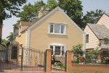

[**A1 – Two Stories Detached (Small or Moderate Size, With or Without Attic)**](https://www.propertyshark.com/info/class-buildings-one-family-dwellings/#a1)

The **A1 building class** includes detached houses which are two stories high. A detached house is a house that is not connected to other houses or dwellings by any walls. The houses in this class can be small or medium sized, with or without an attic. They are the most numerous among all single family dwellings, accounting for 39% of all single family houses in NYC. 59% of these houses are located in Queens, 20% in Staten Island and 15% in Brooklyn.

The neighborhoods with the biggest numbers of single family houses in the A1 building class are: Queens Village, South Ozone Park, St. Albans, Bayside / Bayside Hills, Baisley Park. All 5 of these neighborhoods are in Queens.

The neighborhoods with the biggest numbers of single family houses in the A0 building class are: Bayside Hills, Auburndale, Queens Village, Bay Terrace and Bellerose, all 5 of them in Queens.

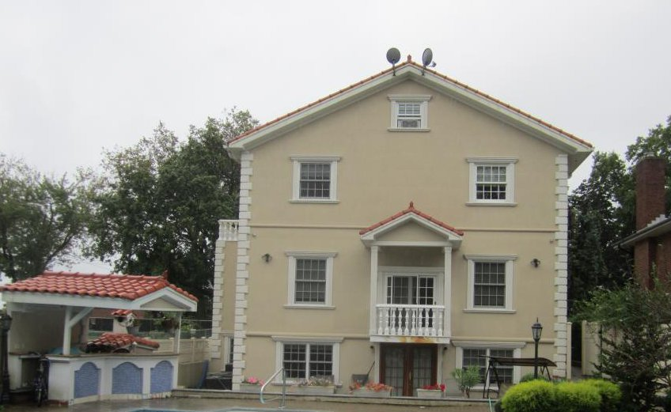

[**A2 – One Story (Permanent Living Quarters)**](https://www.propertyshark.com/info/class-buildings-one-family-dwellings/#a2)

The **A2 building class** comprises one story houses. The A2 class is the third most populous of all the ten single family residential classes, accounting for 16% of such properties. Queens has the highest number of houses in the A2 building class, 58%, followed by Staten Island with 30%.

The neighborhoods with the biggest numbers of single family houses in the A2 building class are: Glen Oaks / Floral Park (Queens), Great Kills (Staten Island), Cambria Heights (Queens), Lindenwood / Howard Beach (Queens) and Laurelton (Queens).

The neighborhoods with the biggest numbers of single family houses in the A0 building class are: Bayside Hills, Auburndale, Queens Village, Bay Terrace and Bellerose, all 5 of them in Queens.

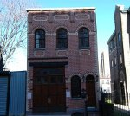

[**A3 – Large Suburban Residence**](https://www.propertyshark.com/info/class-buildings-one-family-dwellings/#a3)

The **A3 building class** comprises large suburban residences. The A3 building class comprises large suburban residences. Over half of these buildings (around 57%) have an area of over 3,000 square feet. The borough with the highest number of class A3 buildings is Queens (46%), followed by Staten Island (29%) and Brooklyn (17%).

The neighborhoods with the biggest numbers of single family houses in the A3 building class are: Forest Hills (Queens), Todt Hill / Emerson Hill / Heartland Village / Lighthouse Hill (Staten Island), Douglas Mnr / Douglaston / Little Neck (Queens), North Riverdale / Fieldston / Riverdale (the Bronx) and Georgetown / Marine Park / Bergen Beach / Mill Basin (Brooklyn).

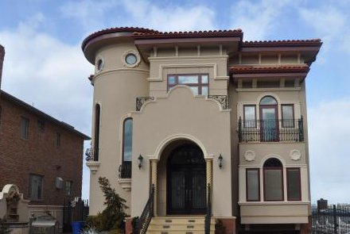

[**A4 – City Residence One Family**](https://www.propertyshark.com/info/class-buildings-one-family-dwellings/#a4)

Properties in the **A4 class** are also called city residences. 99% of them are at least 2 stories high and 55% are at least 3 stories high. The great majority of the A4 buildings can be encountered in Brooklyn (70%) and Manhattan (28%).

The neighborhoods with the biggest numbers of single family houses in the A4 building class are: Crown Heights South (Brooklyn), Carnegie Hill (Manhattan), Prospect-Lefferts Garden / Wingate (Brooklyn), Crown Heights North (Brooklyn) and Park Slope (Brooklyn).

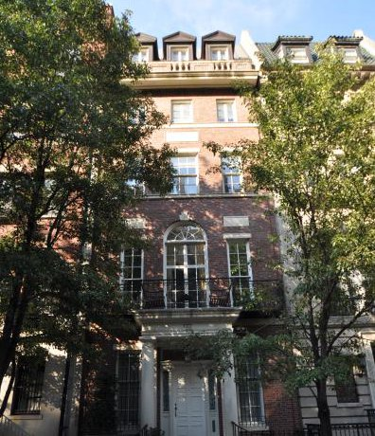

[**A5 – One Family Attached or Semi-Detached**](https://www.propertyshark.com/info/class-buildings-one-family-dwellings/#a5)

Houses in the A5 building class are the second most common among all single family residential dwellings in New York City and they account for 31% of them. This class includes houses that are attached or semi-detached. Attached homes are houses that have two sidewalls in common with other houses, unless the house is at the end of the row. Semi-detached homes are usually symmetrical, sharing a common wall. Houses in the A5 class can be found in significant numbers in Queens (40%), Staten Island (28%) and Brooklyn (22%).

The neighborhoods with the biggest numbers of single family houses in the A5 building class are: Middle Village (Queens), Great Kills (Staten Island), Arden Heights (Staten Island), New Springville / Bloomfield / Travis (Staten Island) and Forest Hills (Queens).

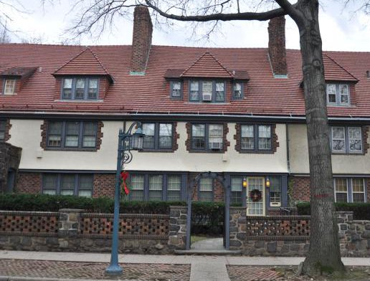

[**A6 – Summer Cottages/Mobile Homes/Trailers**](https://www.propertyshark.com/info/class-buildings-one-family-dwellings/#a6)

The A6 building class includes mobile homes, trailers and summer cottages. Mobile homes are prefabricated houses that are built in factories, not on site. They are then taken to the place where they are to be inhabited. Most A6 properties are found in Staten Island (68%).

The neighborhoods with the biggest numbers of single family houses in the A6 building class are: New Dorp / Midland Beach (Staten Island), Hammels / Arverne / Edgemere (Queens), South Beach / Old Town / Dongan Hills (Staten Island), Far Rockaway / Bayswater (Queens) and Oakwood (Staten Island).

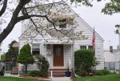

[**A7 – Mansion Type or Town House**](https://www.propertyshark.com/info/class-buildings-one-family-dwellings/#a7)

Properties in the A7 building class are mansion-like buildings. They are not very common: there are 331 of them spread relatively uniformly throughout the 5 boroughs. 109 are in Brooklyn, 97 in Manhattan and 77 in Queens.

The neighborhoods with the biggest numbers of single family houses in the A7 building class are: Carnegie Hill (Manhattan), Homecrest (Brooklyn), Crown Heights South (Brooklyn), North Riverdale / Fieldston / Riverdale (the Bronx) and Jamaica Estates / Holliswood (Queens).

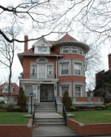

[**A8 – Bungalow Colony/Land Coop Owned**](https://www.propertyshark.com/info/class-buildings-one-family-dwellings/#a8)

There are 29 properties in the A8 class in New York City. Bungalow colonies were built between 1920 and 1940 and are clusters of small rental homes. The number of units in NYC’s bungalow colonies ranges from 3 to 1885. From the 29 colonies in New York City, 26 are in the Bronx and 3 are in Queens.

There are only 3 neighborhoods where these properties can be found: 25 are in Schuylerville / Throgs Neck / Edgwater Park (the Bronx), 3 are in Breezy Point (Queens) and 1 is in City Island (the Bronx).

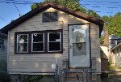

[**A9 – Miscellaneous One Family**](https://www.propertyshark.com/info/class-buildings-one-family-dwellings/#a9)

Properties in the **A9 class** are miscellaneous buildings that are not part of any other class. 57% of them are in Brooklyn and 24% in Staten Island. The class consists of attached or semi-detached frame houses (houses with very steep roofs that go down almost all the way to the ground), old houses, etc.

The neighborhoods with the biggest numbers of single family houses in the A9 building class are: Flatlands (Brooklyn), Georgetown / Marine Park / Bergen Beach / Mill Basin (Brooklyn), East Flatbush / Farragut (Brooklyn), Great Kills (Staten Island) and Arden Heights / Greenridge (Staten Island).

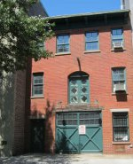

## Class B Buildings - Two Family Dwellings

[SOURCE: https://www.propertyshark.com/info/class-b-buildings-two-family-dwellings/#b1](https://www.propertyshark.com/info/class-b-buildings-two-family-dwellings/#b1)

[**B1 – Two Family Brick**](https://www.propertyshark.com/info/class-b-buildings-two-family-dwellings/#b1)

Properties in the B1 building class are two-family dwellings made of brick. They are the most numerous two-family dwellings in New York City, accounting for 34% of them. They are predominant in Brooklyn, where 48% of these buildings are located, followed by Queens (31%) and Staten Island (17%).

The top 5 neighborhoods where B1 two-family homes are most numerous are Canarsie (Brooklyn), Borough Park (Brooklyn), Bay Ridge (Brooklyn), Flatlands (Brooklyn) and Ridgewood (Queens).

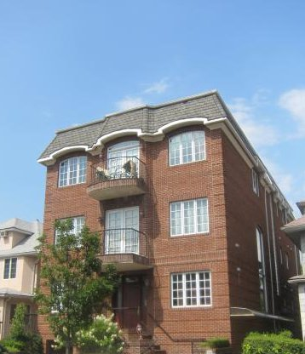

[**B2 – Two Family Frame**](https://www.propertyshark.com/info/class-b-buildings-two-family-dwellings/#b2)

Properties in the B2 building class are frame-built two-family dwellings that are most numerous in Queens (40%), Brooklyn (25%) and Staten Island (24%).

The top 5 neighborhoods for properties in the B2 building class are New Springville / Bloomfield / Travis (Staten Island), Bushwick South (Brooklyn), Eltingville / Annadale / Huguenot / Blue Heron Park / Wolfe’s Pond Park / Mount Loretto (Staten Island), East New York – part A (Brooklyn) and South Ozone Park (Queens).

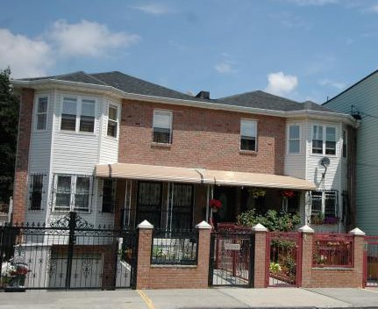

[**B3 – Two Family Converted (From One Family)**](https://www.propertyshark.com/info/class-b-buildings-two-family-dwellings/#b3)

The B3 building class comprises two-family dwellings that were converted from one family homes. Over half of them (53%) are in Queens, 34% in Brooklyn and 8% in the Bronx.

The neighborhoods with the greatest numbers of properties in the B3 building class are South Ozone Park (Queens), Stuyvesant Heights (Brooklyn), Richmond Hill (Queens), St. Albans (Queens) and Bensonhurst West (Brooklyn).

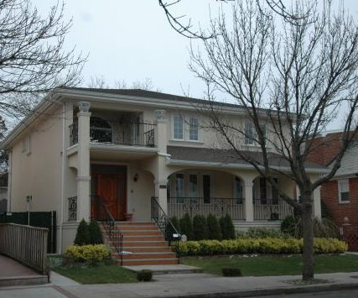

[**B9 – Miscellaneous Two Family**](https://www.propertyshark.com/info/class-b-buildings-two-family-dwellings/#b9)

Properties in the B9 building class are miscellaneous two-family dwellings that are not part of B1, B2 or B3. A great number (60%) are in Brooklyn, with 22% in Staten Island and 9% in Queens.

Here are the top 5 neighborhoods with the greatest number of properties in the B9 building class: Sunset Park (Brooklyn), Canarsie (Brooklyn), Crown Heights North (Brooklyn), Sheepshead Bay / Gerritsen Beach / Manhattan Beach (Brooklyn), Great Kills (Staten Island).

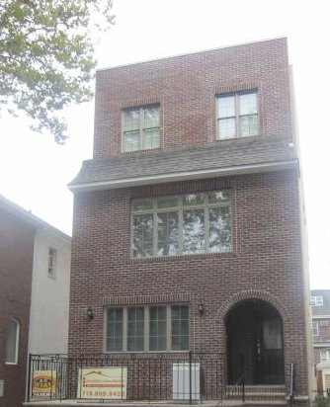

## Class C Buildings - Multiple Family Dwellings

[SOURCE: https://www.propertyshark.com/info/class-c-buildings-walk-apartments/ - c0](https://www.propertyshark.com/info/class-c-buildings-walk-apartments/#c0)

[**C0 – Three Families**](https://www.propertyshark.com/info/class-c-buildings-walk-apartments/#c0)

Properties in the C0 building class are 3-family walk-up apartment buildings. C0 is by far the most numerous among all class C buildings, accounting for 54% of them. 49% of all properties in the C0 class are in Brooklyn, with 33% in Queens and 15% in the Bronx.

The top 5 neighborhoods with the biggest numbers of properties in the C0 building class are Borough Park (Brooklyn), Bensonhurst West (Brooklyn), Elmhurst (Queens), Stuyvesant Heights (Brooklyn) and Astoria (Queens).

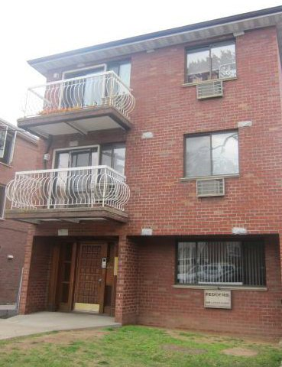

[**C1 – Over Six Families Without Stores**](https://www.propertyshark.com/info/class-c-buildings-walk-apartments/#c1)

The C1 building class comprises buildings that accommodate over 6 families and don’t have stores. Almost half of them (47%) are in Brooklyn, with 20% in the Bronx and 17% in Manhattan.

Here are the 5 neighborhoods with the greatest numbers of these buildings: Crown Heights North (Brooklyn), Astoria (Queens), Flatbush (Brooklyn), Greenpoint (Brooklyn) and Park Slope (Brooklyn).

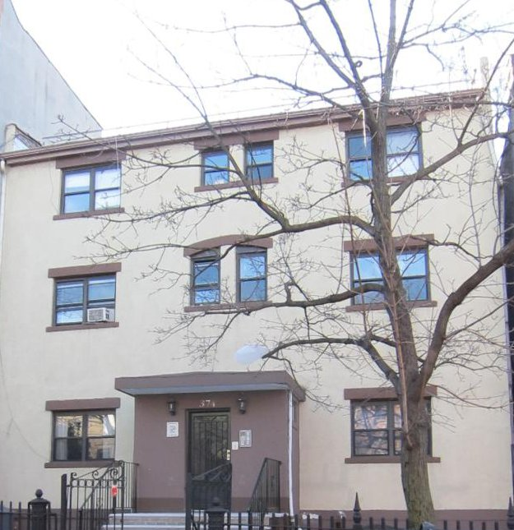

[**C2 – Five to Six Families**](https://www.propertyshark.com/info/class-c-buildings-walk-apartments/#c2)

Properties in the C2 class are buildings that accommodate 5 to 6 families. Over half of them (57%) are in Brooklyn, with 32% in Queens and 6% in the Bronx.

The top 5 neighborhoods with these buildings are Bushwick North (Brooklyn), Ridgewood (Queens), Astoria (Queens), Greenpoint (Brooklyn) and Bushwick South (Brooklyn).

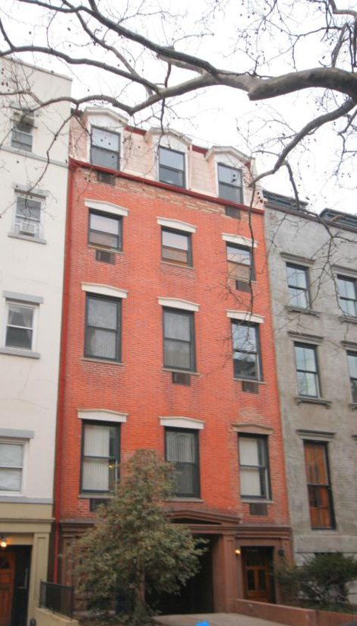

[**C3 – Four Families**](https://www.propertyshark.com/info/class-c-buildings-walk-apartments/#c3)

Properties in the C3 class are four-family walk-up apartment buildings that are most numerous in Brooklyn (59%), Queens (22%) and the Bronx (12%).

The neighborhoods where these buildings are the most numerous are Ridgewood (Queens), Rugby / Remsen Village (Brooklyn), Bensonhurst West (Brooklyn), Carroll Gardens / Columbia / RedHook (Brooklyn) and Brownsville (Brooklyn).

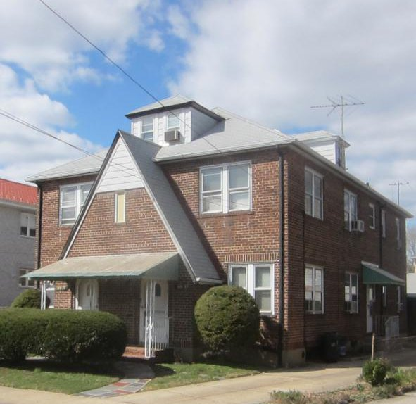

[**C4 – Old Law Tenements**](https://www.propertyshark.com/info/class-c-buildings-walk-apartments/#c4)

Buildings in the C4 class are old law tenements built in New York City between 1879 and 1901. These buildings are also called “dumbbell tenements” because they are shaped like a dumbbell, wide at their edges and narrow in the middle. This was done in order to create air corridors between them. The majority of these buildings can be found in Manhattan (78%), Brooklyn (14%) and the Bronx (7%).

Buildings in the C4 class are most numerous in Hell’s Kitchen, East Village, Central Harlem South, Central Harlem North and Hudson Yards / Chelsea / Flatiron / Union Square, all in Manhattan.

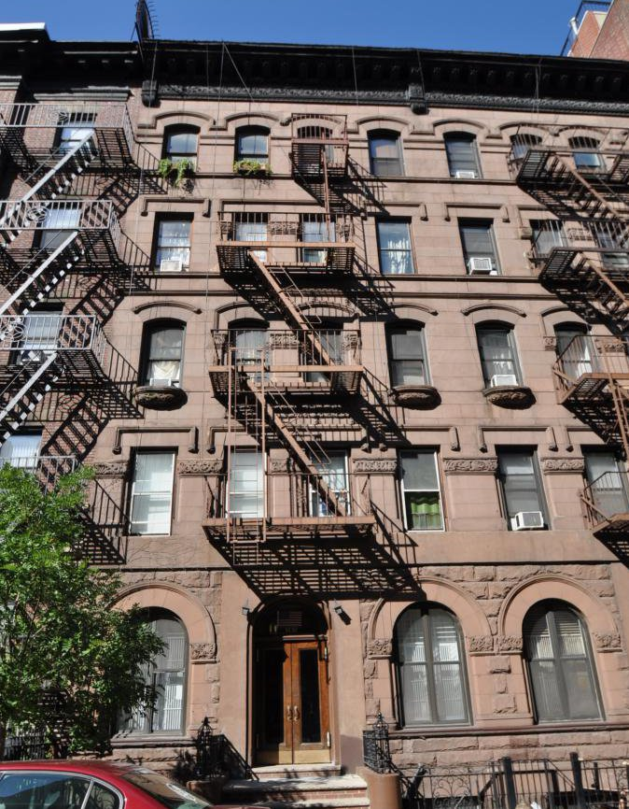

[**C5 – Converted Dwelling or Rooming House**](https://www.propertyshark.com/info/class-c-buildings-walk-apartments/#c5)

The C5 building class comprises converted dwellings or rooming houses. Most of these buildings are found in Manhattan (79%) and Brooklyn (14%).

The neighborhoods with the biggest numbers of properties in the C5 building class are Upper West Side, Central Harlem North, Central Harlem South, Lincoln Square and Hamilton Heights, all in Manhattan.

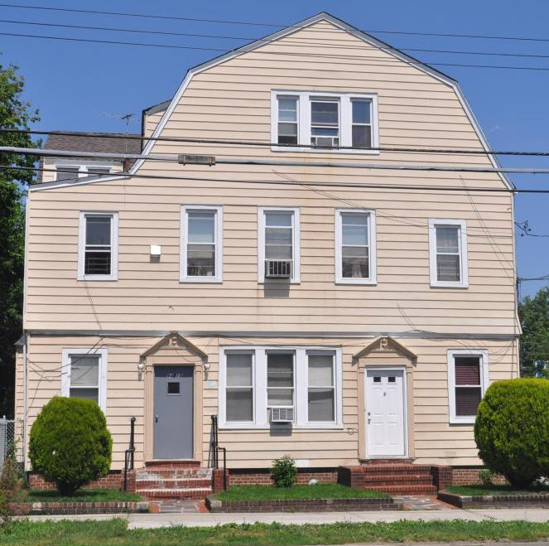

[**C6 – Walk-up Cooperative**](https://www.propertyshark.com/info/class-c-buildings-walk-apartments/#c6)

Properties in the C6 class are walk-up coop buildings. 45% of them are in Manhattan, with 39% in Brooklyn and 10% in Queens.

Park Slope (Brooklyn), Upper West Side (Manhattan), West Village (Manhattan), Hudson Yards / Chelsea / Flatiron / Union Square (Manhattan) and Brooklyn Heights (Brooklyn) are the New York City neighborhoods where C6 buildings can be found in their biggest numbers.

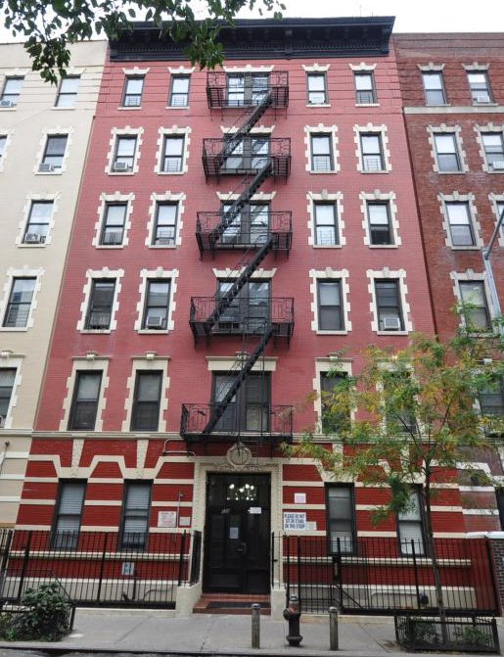

[**C7 – Walk-up Apartments Over Six Families With Stores**](https://www.propertyshark.com/info/class-c-buildings-walk-apartments/#c7)

The C7 building class comprises walk-up apartment buildings that accommodate over 6 families and have stores. They can be found mostly in Manhattan (60%), Brooklyn (20%) and the Bronx (15%).

They are in greatest numbers in Chinatown, East Village, Yorkville, SoHo / Tribeca / Civic Central / Little Italy and West Village (all 5 of them in Manhattan).

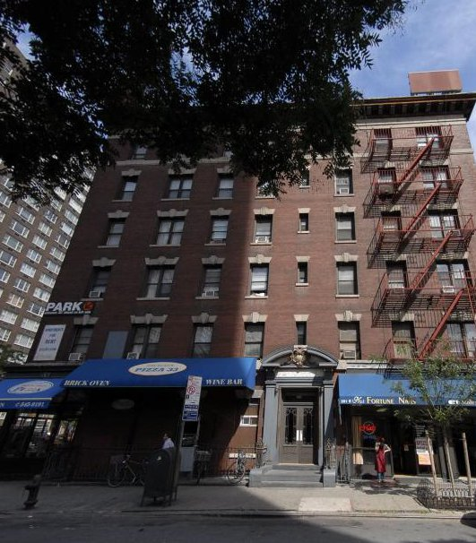

[**C8 – Walk-up Co-op; Conversion From Loft/Warehouse**](https://www.propertyshark.com/info/class-c-buildings-walk-apartments/#c8)

The C8 class comprises coop buildings converted from lofts or warehouses. There are only 18 such buildings in New York City, 12 in Manhattan and 6 in Brooklyn.

There are 9 of these buildings in Soho / Tribeca / Civic Central / Little Italy (Manhattan), 3 in Crown Heights North (Brooklyn) and one in each of the following neighborhoods: West Village (Manhattan), Stuyvesant Heights (Brooklyn), Upper West Side (Manhattan), North Side / South Side (Brooklyn), Chinatown (Manhattan) and Sheepshead Bay / Gerritsen Beach / Manhattan Beach (Brooklyn).

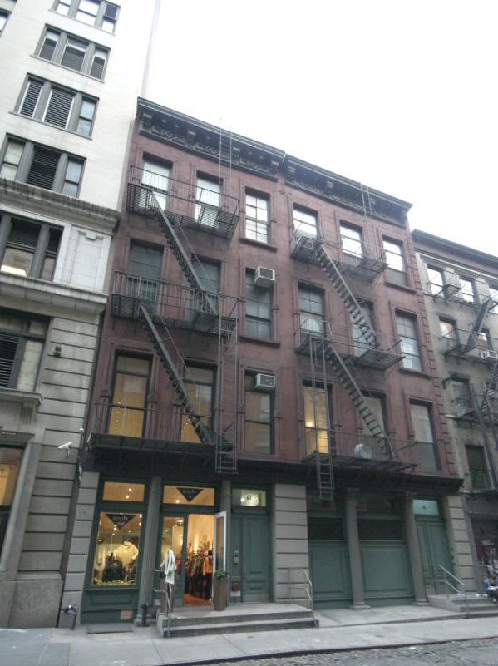

[**C9 – Garden Apartments/Mobile Home Park/Trailer Park**](https://www.propertyshark.com/info/class-c-buildings-walk-apartments/#c9)

Properties in the C9 class are walk-up apartment buildings comprising garden apartments, or mobile home parks and trailer parks. They are distributed across the boroughs as follows: 184 are in Queens, 88 in Staten Island, 53 in both Brooklyn and the Bronx, and 48 in Manhattan.

The top 5 neighborhoods where these buildings can be found are Steinway (Queens), Kew Gardens Hills (Queens), Central Harlem North (Manhattan), Bayside / Bayside Hills (Queens), and BreezyPoint / BelleHarbor / RockawayPark / Broad Channel (Queens).

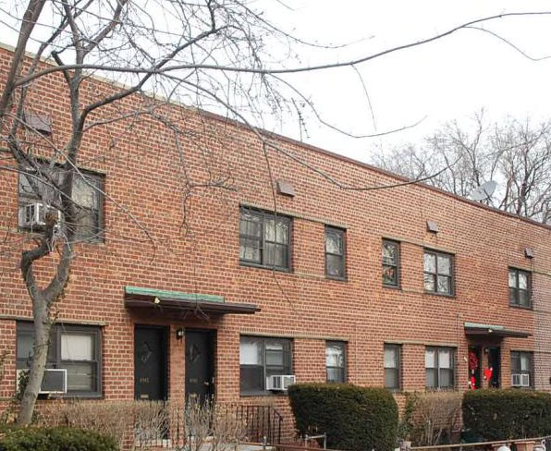

## Class D Buildings - Elevator Apartments

SOURCE: <https://www.propertyshark.com/info/class-d-buildings-elevator-apartments/#d0>

[**D0 – Elevator Co-op; Conversion From Loft/Warehouse**](https://www.propertyshark.com/info/class-d-buildings-elevator-apartments/#d0)

The D0 class comprises coop elevator apartment buildings that were converted from lofts or warehouses.

The vast majority of them (98%) are located in Manhattan, especially in SoHo / Tribeca / Civic Central / Little Italy, Hudson Yards / Chelsea / Flatiron / Union Square and West Village.

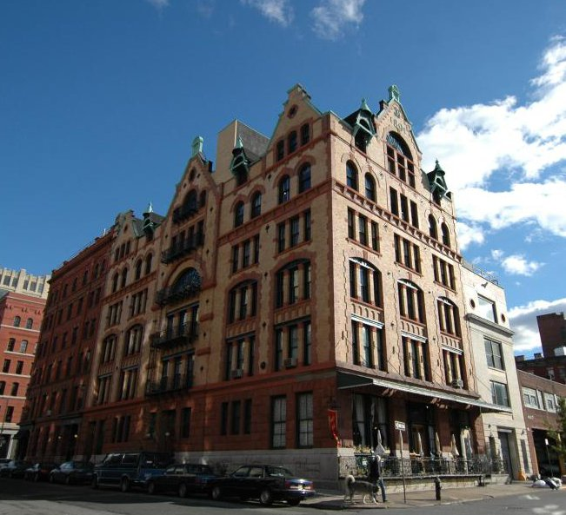

[**D1 – Elevator Apt; Semi-fireproof (Without Stores)**](https://www.propertyshark.com/info/class-d-buildings-elevator-apartments/#d1)

The D1 class comprises elevator apartment buildings that are semi-fireproof and without stores. They can be found in all 5 boroughs, especially in Brooklyn (34%), the Bronx (29%) and Manhattan (21%). They are the most numerous buildings among all class D properties.

The neighborhoods where these properties can be found in the greatest numbers are Flatbush (Brooklyn), Prospect / Lefferts Gardens / Wingate (Brooklyn), Washington Heights South (Manhattan), Bedford Park / Fordham North (the Bronx) and Hamilton Heights (Manhattan).

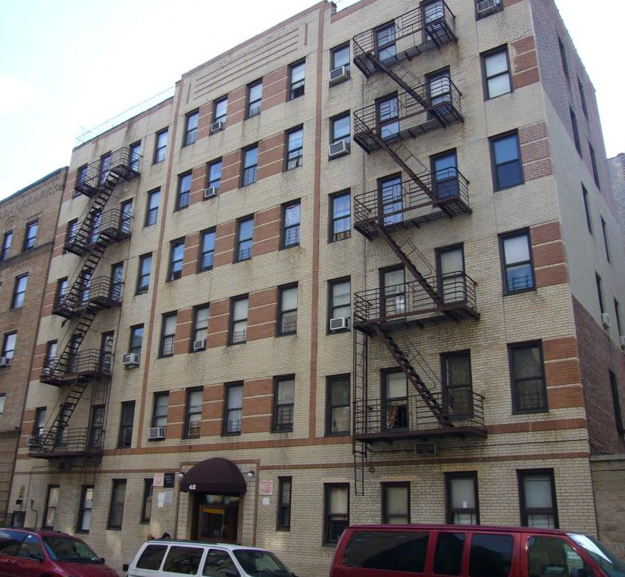

[**D2 – Elevator Apt; Artists in Residence**](https://www.propertyshark.com/info/class-d-buildings-elevator-apartments/#d2)

There are 74 buildings in the D2 class in New York City. 54 are in Manhattan, 19 in Brooklyn and 1 in Queens. They are former industrial lofts transformed into residential buildings according to the “artist in residence” law. The law states that each occupied apartment should be inhabited by a certified artist.

Most of these buildings in NYC can be found in Soho / Tribeca / Civic Central / Little Italy and the West Village, and on the Upper West Side, Upper East Side and North Side.

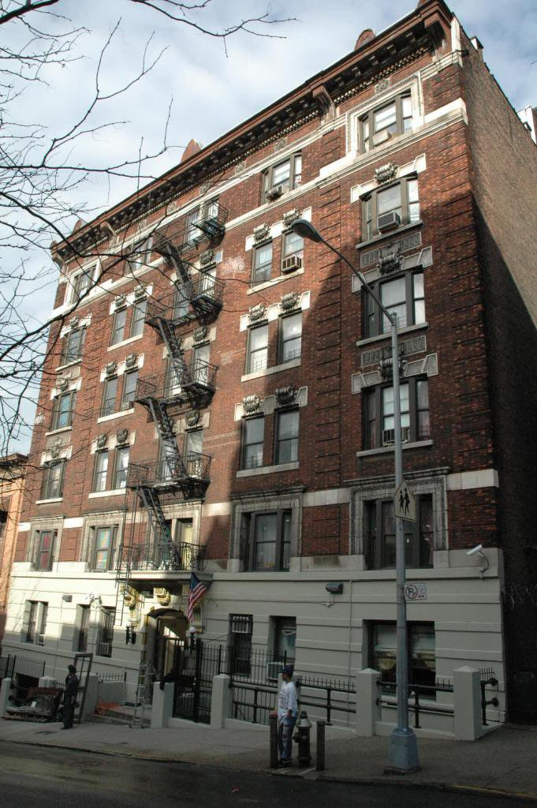

[**D3 – Elevator Apt; Fireproof (Standard Construction Without Stores)**](https://www.propertyshark.com/info/class-d-buildings-elevator-apartments/#d3)

The D3 class consists of elevator apartment buildings that are fireproof and don’t have stores. They can be encountered most frequently in Manhattan, where almost half of them are situated (47%), followed by Brooklyn (20%) and the Bronx (17%).

The top 5 neighborhoods where these buildings are located are Upper West Side, Morningside Heights, Lower East Side, Central Harlem North and East Harlem North, all in Manhattan.

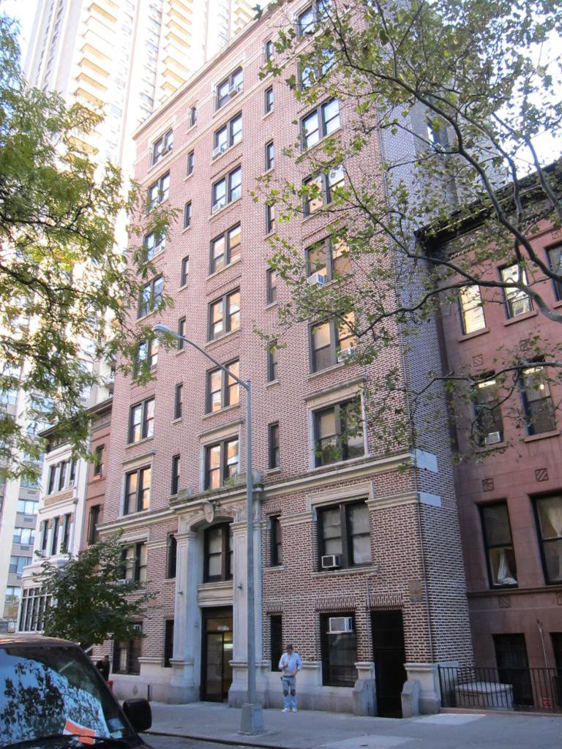

[**D4 – Elevator Cooperatives**](https://www.propertyshark.com/info/class-d-buildings-elevator-apartments/#d4)

The D4 building class comprises elevator buildings with coops, other than condominiums. They are the second most numerous buildings from all D building classes. Over half of them (54%) are in Manhattan, 20% in Queens and 18% in Brooklyn.

The neighborhoods where they are the most popular are Upper East Side / Carnegie Hill (Manhattan), Upper West Side (Manhattan), Forest Hills (Queens), Turtle Bay / East Midtown (Manhattan) and Yorkville (Manhattan).

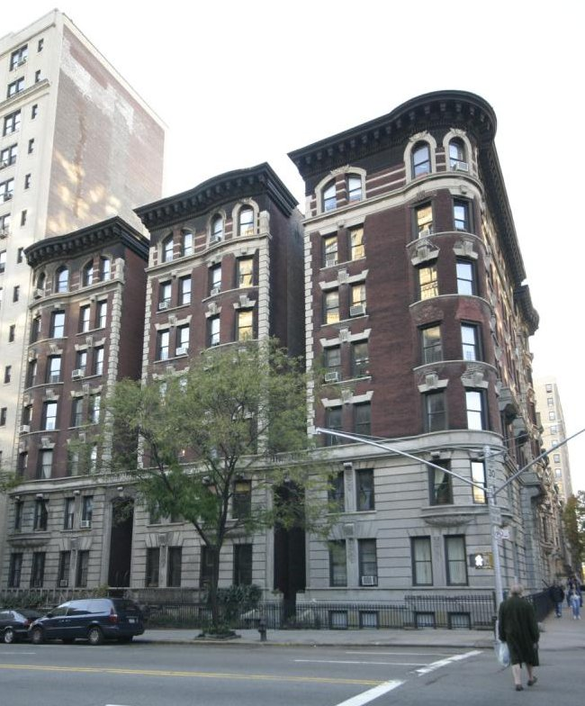

[**D5 – Elevator Apt; Converted**](https://www.propertyshark.com/info/class-d-buildings-elevator-apartments/#d5)

The D5 building class comprises converted elevator apartments. Over half of them are in Manhattan (52%), with 25% in the Bronx and 20% in Brooklyn.

They can be found in the biggest numbers in West Village (Manhattan), University Heights / Morris Heights (the Bronx), Hunts Point (the Bronx), SoHo / Tribeca / Civic Central / Little Italy (Manhattan) and Longwood (the Bronx).

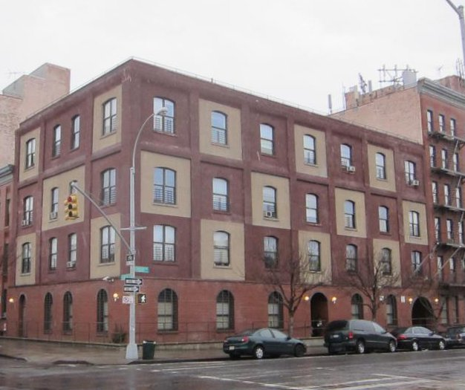

[**D6 – Elevator Apt; Fireproof – With Stores**](https://www.propertyshark.com/info/class-d-buildings-elevator-apartments/#d6)

The D6 class consists of fireproof elevator apartment buildings that have stores. A great majority of them, 78%, are in Manhattan, 9% are in Queens and 7% in Brooklyn.

Top 5 neighborhoods where they are the most popular all in Manhattan: the Upper West Side, Upper East Side / Carnegie Hill, Yorkville, Lenox Hill and Hudson Yards / Chelsea / Flatiron / Union Square.

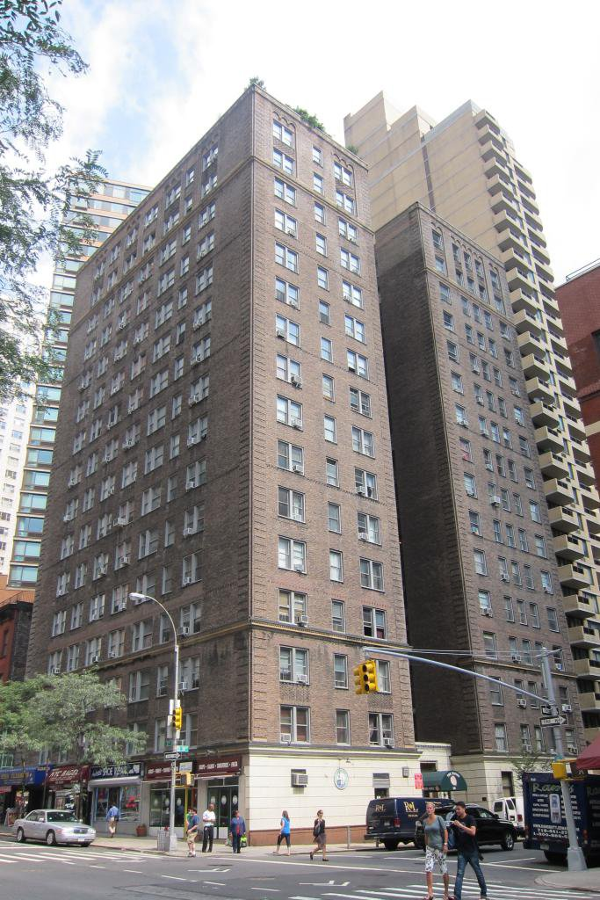

[**D7 – Elevator Apt; Semi-Fireproof With Stores**](https://www.propertyshark.com/info/class-d-buildings-elevator-apartments/#d7)

The D7 building class consists of semi-fireproof elevator apartments with stores. 43% of these buildings are in Manhattan, 25% in the Bronx and 19% in Brooklyn.

The 5 neighborhoods with the biggest numbers of properties in the D7 class are Washington Heights South (Manhattan), Washington Heights North (Manhattan), Upper West Side (Manhattan), Hamilton Heights (Manhattan) and East Concourse (the Bronx).

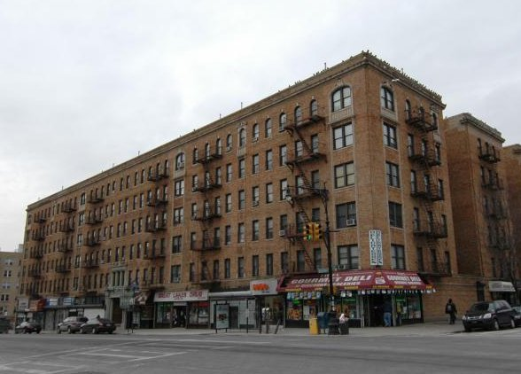

[**D8 – Elevator Apt; Luxury Type**](https://www.propertyshark.com/info/class-d-buildings-elevator-apartments/#d8)

The D8 building class is made up of luxury elevator apartment buildings that can mostly be found in Manhattan.

They are most numerous in Battery Park City / Lower Manhattan, Hudson Yards / Chelsea / Flatiron / Union Square, Turtle Bay / East Midtown, West Village (all in Manhattan) and in Hunters Point / Sunnyside / West Maspeth Queens.

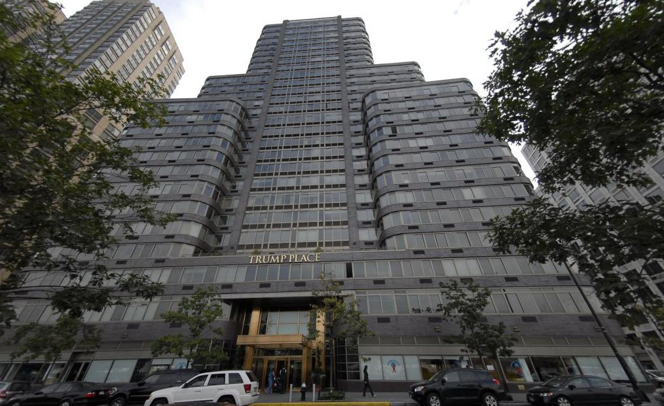

[**D9 – Elevator Apt; Miscellaneous**](https://www.propertyshark.com/info/class-d-buildings-elevator-apartments/#d9)

Other types of elevator apartments that can not be classified in any of the classes from D0 to D8 are part of the D9 building class. As is the case with the great majority of other D building classes, these properties can mostly be found in Manhattan (68%). The borough that comes second is Brooklyn, with 21%.

The top neighborhoods where these buildings can be found are the Upper West Side, Murray Hill / Kips Bay, Upper East Side / Carnegie Hill, Lenox Hill and Gramercy, all of them in Manhattan.

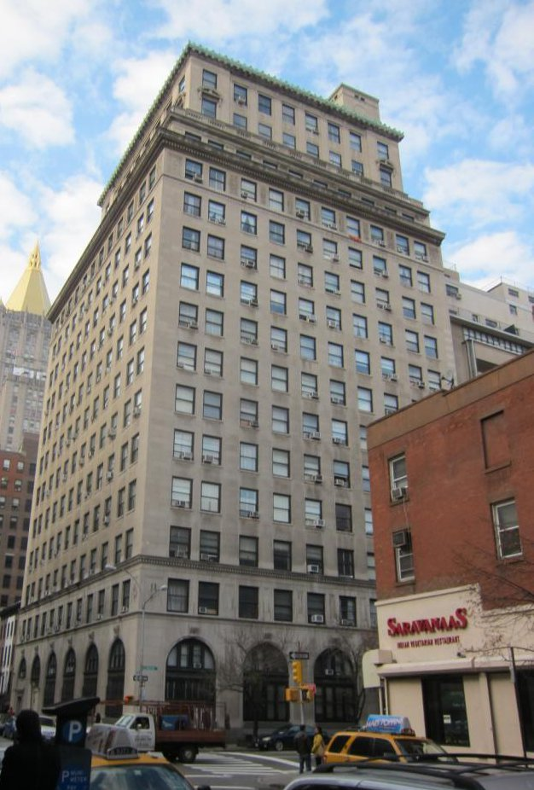

## Class R Buildings - Condominiums

SOURCE: <https://www.propertyshark.com/info/class-r-buildings-condominiums/#r0>

[**R0 – special condominium billing lot**](https://www.propertyshark.com/info/class-r-buildings-condominiums/#r0)

The R0 building class comprises buildings with condo units. While the buildings fall under the R0 property class, the condo units themselves fall under other R codes.

These condo buildings are most numerous in Brooklyn, where 47% of them can be found, followed by Manhattan (35%) and Queens (13%).

The top 5 neighborhoods where these buildings can be found are Borough Park (Brooklyn), SoHo / Tribeca / Civic Central / Little Italy (Manhattan), Hudson Yards / Chelsea / Flatiron / Union Square (Manhattan), West Village (Manhattan) and Bedford (Brooklyn).

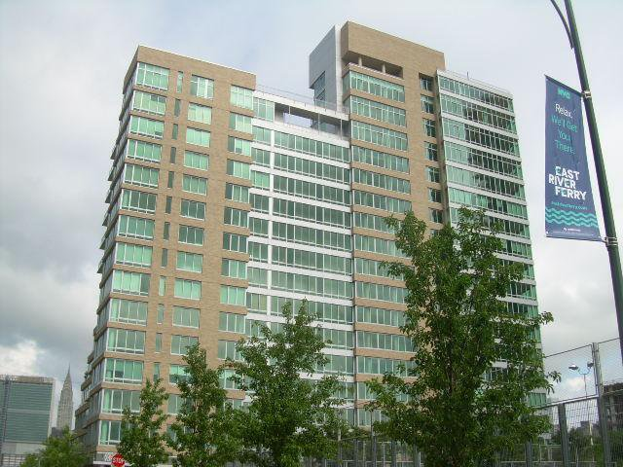

[**R1 – condo; residential unit in 2-10 unit bldg.**](https://www.propertyshark.com/info/class-r-buildings-condominiums/#r1)

The R1 building class comprises condo units in residential buildings that have 2 to 10 units. They are most popular in Brooklyn (61%), Manhattan (31%) and Queens (7%).

The neighborhoods where they can be found in their biggest numbers are SoHo / Tribeca / Civic Central / Little Italy (Manhattan), Park Slope (Brooklyn), Bedford (Brooklyn), East Williamsburg (Brooklyn) and Clinton Hill (Brooklyn).

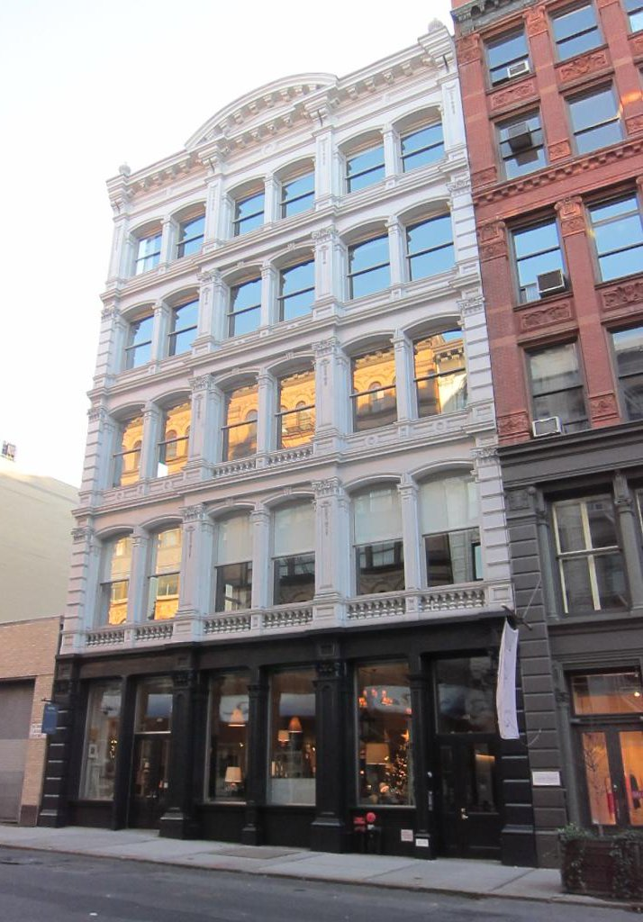

[**R2 – condo; residential unit in walk-up bldg.**](https://www.propertyshark.com/info/class-r-buildings-condominiums/#r2)

The R2 building class consists of walk-up residential units. They are most numerous in Brooklyn (45%), Queens (32%) and Manhattan (13%).

The top 5 neighborhoods with the biggest numbers of R2 units are Steinway (Queens), Clinton Hill (Brooklyn), Park Slope (Brooklyn), Kew Gardens Hills (Queens) and Borough Park (Brooklyn).

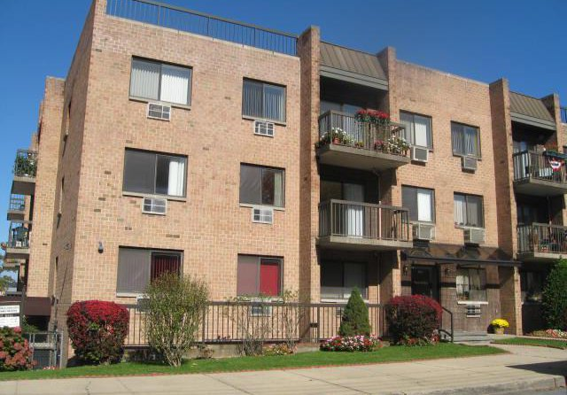

[**R3 – condo; residential unit in 1-3 story bldg.**](https://www.propertyshark.com/info/class-r-buildings-condominiums/#r3)

The R3 building class comprises residential units in buildings that are 1-3 stories high. They are distributed relatively evenly in Staten Island, Brooklyn and Queens. These 3 boroughs account for 34%, 30% and 26% of them respectively. These units are not very common in Manhattan.

The neighborhoods with the biggest numbers of these buildings are Todt Hill / Emerson Hill / Heartland Village / Lighthouse Hill (Staten Island), Mariner’s Harbor / Arlington / Port Ivory / Graniteville (Staten Island), New Springville / Bloomfield / Travis (Staten Island), Fort Totten / Bay Terrace / Clearview (Queens) and Canarsie (Brooklyn).

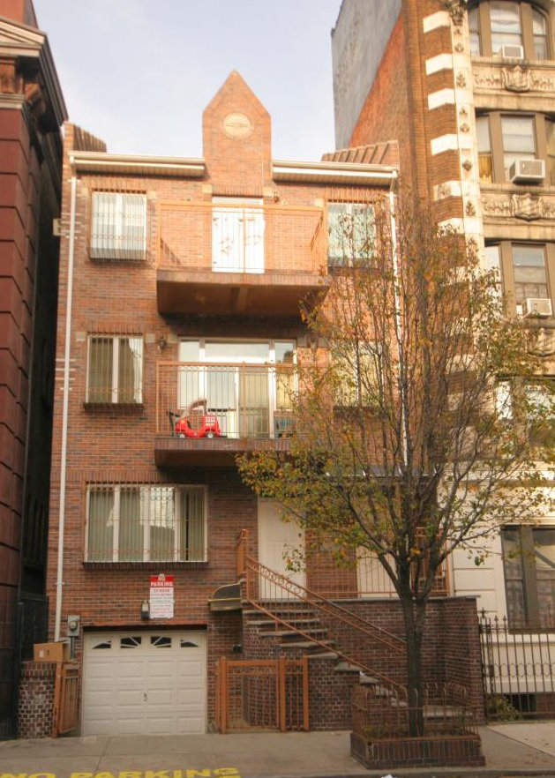

[**R4 – condo; residential unit in elevator bldg.**](https://www.propertyshark.com/info/class-r-buildings-condominiums/#r4)

The R4 building class comprises residential units that are common in high buildings. That’s why the majority of these units can be found in Manhattan (61%). It is followed by Brooklyn (15%) and Queens (13%).

The R4 building class is by far the most numerous in the R-class group, accounting for 65% of all buildings and units in this classification. Somewhat surprisingly, the neighborhood with the biggest number of these buildings is Parkchester in the Bronx. It is followed by 4 Manhattan neighborhoods: Lincoln Square, Battery Park City / Lower Manhattan, the Upper West Side and Turtle Bay / East Midtown.

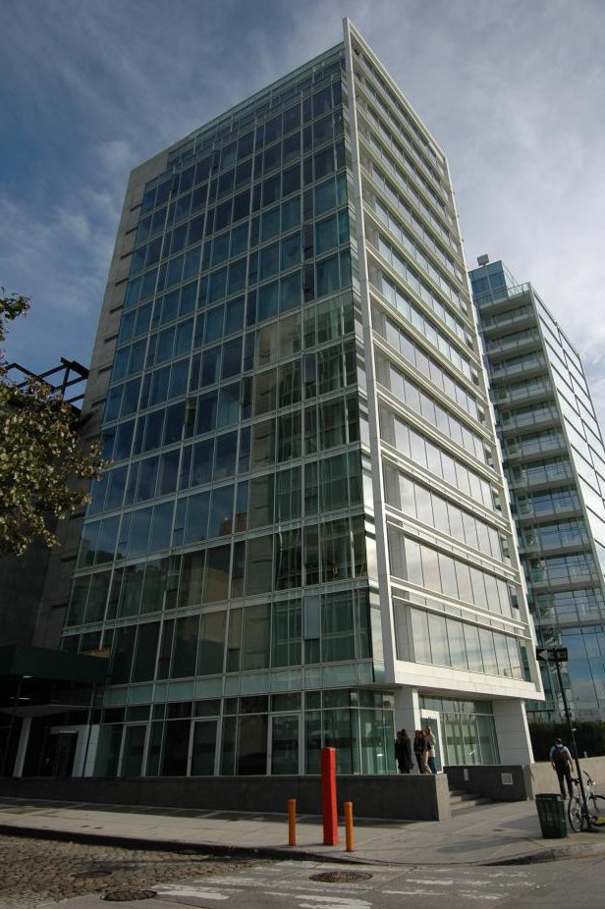

[**R5 – miscellaneous commercial**](https://www.propertyshark.com/info/class-r-buildings-condominiums/#r5)

The R5 building class is made up of commercial units and is common in Manhattan (36%), Brooklyn (33%) and Queens (27%).

R5 class properties are most numerous in Flushing (Queens), Midtown / Midtown South (Manhattan), SoHo / Tribeca / Civic Central / Little Italy (Manhattan), Lincoln Square (Manhattan) and North Side / South Side (Brooklyn).

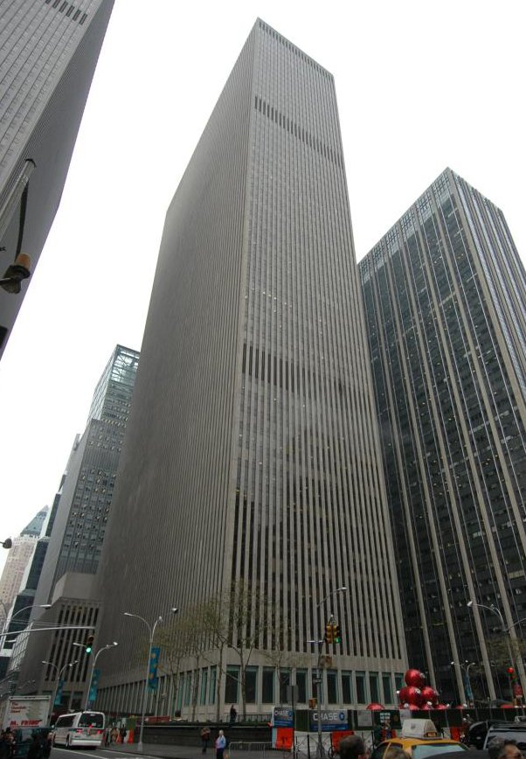

[**R6 – condo; resid.unit of 1-3 unit bldg-orig class 1**](https://www.propertyshark.com/info/class-r-buildings-condominiums/#r6)

The R6 building class comprises residential units in buildings that have 1 to 3 units. Most of these units can be found in Brooklyn (83%) and Manhattan (14%).

The neighborhoods where these units can be found most frequently are Borough Park (Brooklyn), Williamsburg (Brooklyn), Park Slope (Brooklyn), Carroll Gardens / Columbia / Red Hook (Brooklyn) and Clinton Hill (Brooklyn).

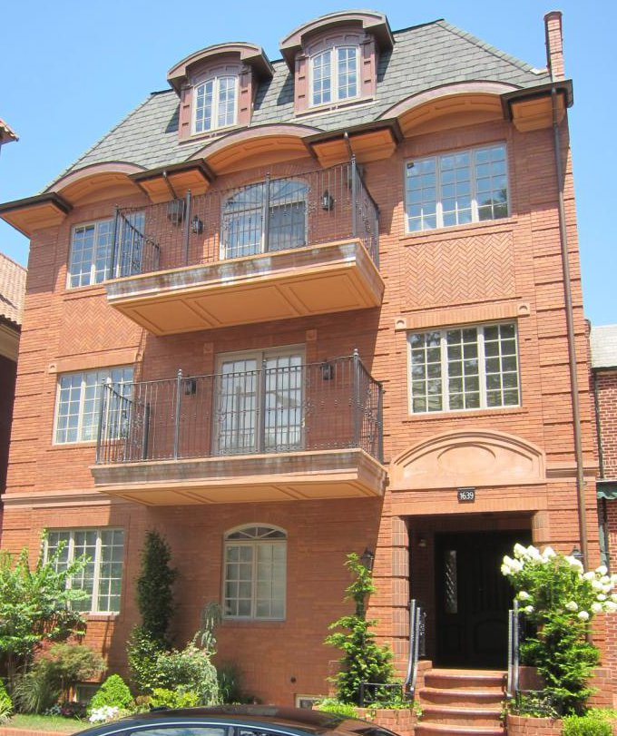

[**R7 – condo; comml.unit of 1-3 unit bldg-orig class 1**](https://www.propertyshark.com/info/class-r-buildings-condominiums/#r7)

The units in the R7 building class are commercial units in buildings that are 1-3 stories high. They are not very common and most of them (29) are in Brooklyn, particularly in Borough Park and Williamsburg.

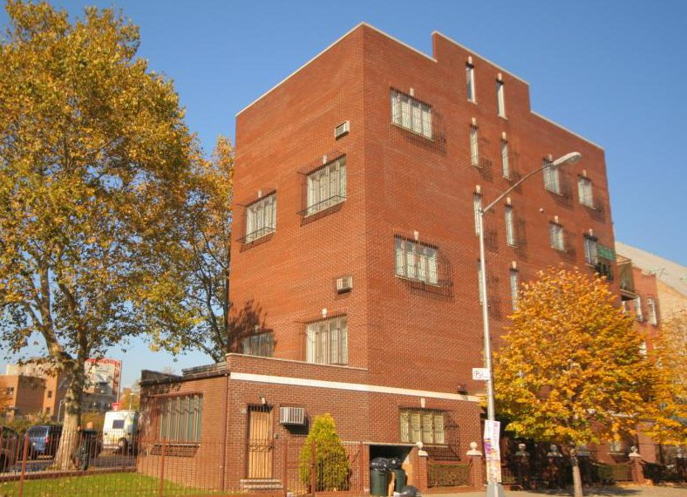

[**R8 – condo; comml.unit of 2-10 unit bldg.**](https://www.propertyshark.com/info/class-r-buildings-condominiums/#r8)

The R8 building class is made up of commercial units that can be found in residential buildings of 2-10 units. They can mostly be found in Manhattan (51%) and Brooklyn (39%).

The neighborhoods where they are present in the biggest numbers are SoHo / Tribeca / Civic Central / Little Italy (Manhattan), Hudson Yards / Chelsea / Flatiron / Union Square (Manhattan), West Village (Manhattan), Flushing (Queens) and Williamsburg (Brooklyn).

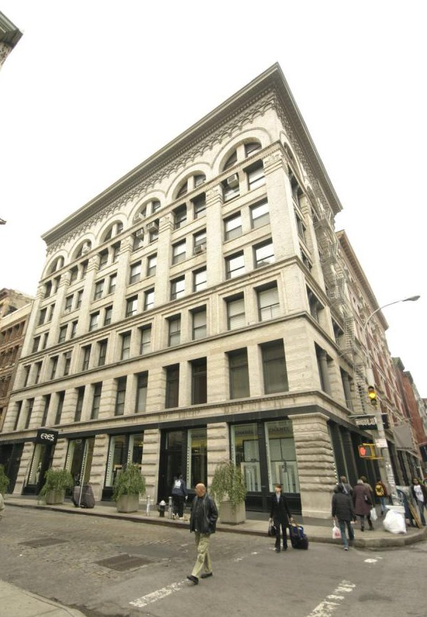

[**R9 – co-op within a condominium**](https://www.propertyshark.com/info/class-r-buildings-condominiums/#r9)

The R9 property class comprises condops. Condops are condominium coops. Most of them are in Manhattan (70%). 17% are in Brooklyn and 11% are in Queens.

The neighborhoods with the biggest numbers of these units are West Village, SoHo / Tribeca / Civic Central / Little Italy, the Upper East Side / Carnegie Hill, Hudson Yards / Chelsea / Flatiron / Union Square and Lenox Hill, all of them in Manhattan.



[**RA – cultural, medical, educational, etc.**](https://www.propertyshark.com/info/class-r-buildings-condominiums/#ra)

The RA building class covers structures dedicated for cultural, medical, educational or other types of public use. Buildings in this class are most frequent in Manhattan (60% of city total), Brooklyn (20%) and Queens (18%).  
The neighborhoods with the most RA class buildings are Kips Bay, Lincoln Square and Greenwich Village in Manhattan, Downtown Flushing in Queens, and Williamsburg in Brooklyn.

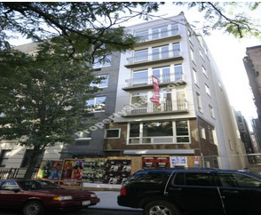

[**RB – office space**](https://www.propertyshark.com/info/class-r-buildings-condominiums/#rb)

The RB building class designates commercial units within residential condominium buildings, used as office space. Units classified as RB are most frequent in Manhattan (60% of city total), Queens (25%) and Brooklyn (12%).  
The neighborhoods with the most RB class units are Downtown Flushing in Queens, Central Midtown, Chinatown, FiDi and Murray Hill in Manhattan.

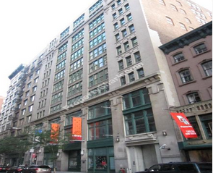

[**RG – indoor parking**](https://www.propertyshark.com/info/class-r-buildings-condominiums/#rg)

The RG building class designates units of indoor parking. Units classified as RG are most frequent in Brooklyn (46% of city total) and Queens (43%).  
The neighborhoods with the most RG class units are Downtown Flushing, Murray Hill, South Astoria and Rego Park in Queens, and Williamsburg in Brooklyn.

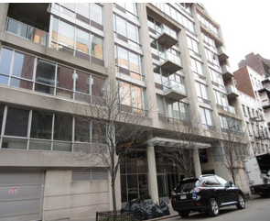

[**RH – hotel/boatel**](https://www.propertyshark.com/info/class-r-buildings-condominiums/#rh)

The RH building class covers hotels and boatels. Almost all buildings in this class are in Manhattan (99%), and the highest concentration can be found in the following neighborhoods: Hudson Square, Lincoln Square, the Theatre District, Central Midtown and Turtle Bay.

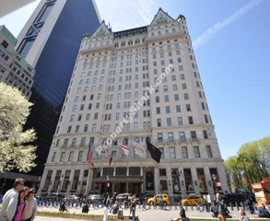

[**RK – retail space**](https://www.propertyshark.com/info/class-r-buildings-condominiums/#rk)

The RK building class designates retail buildings and units in commercial or mixed-use buildings. The majority of buildings in this class are in Manhattan (67% of city total), while 17% can be found in Queens and 12% in Brooklyn.  
The neighborhoods with the highest concentration of RK class buildings are Chelsea, Lenox Hill, TriBeCa and the Upper West Side in Manhattan, and Downtown Flushing in Queens.

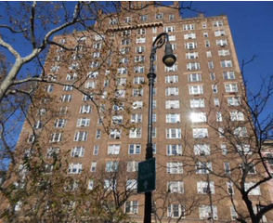

[**RP – outdoor parking**](https://www.propertyshark.com/info/class-r-buildings-condominiums/#rp)

The RP building class designates units of outdoor parking. Units classified as RP are most frequent in Brooklyn (65% of city total) and Queens (31%).  
The neighborhoods with the most RP class units are Coney Island, Gravesend, Sheepshead Bay and Brighton Beach in Brooklyn, and Downtown Flushing in Queens.

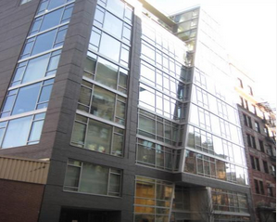

[**RS – non-business storage space**](https://www.propertyshark.com/info/class-r-buildings-condominiums/#rs)

The RS building class designates units of storage space destined for non-business use. Units classified as RS are most frequent in Manhattan (70% of city total) and Brooklyn (21%).  
The neighborhoods with the most RS class units are all in Manhattan: Lincoln Square, Lenox Hill, Clinton – Hell’s Kitchen, Carnegie Hill and Yorkville.

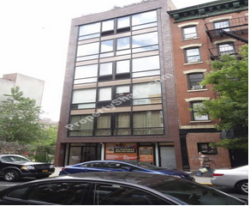

[**RT – terraces/gardens/cabanas**](https://www.propertyshark.com/info/class-r-buildings-condominiums/#rt)

The RT building class designates various constructions in or around a main building. Units classified as RT are most frequent in Brooklyn (64% of city total) and Queens (26%).  
The neighborhoods with the most RT class units are Williamsburg, Downtown Brooklyn, Brooklyn Heights and Sheepshead Bay in Brooklyn, and Hunters Point in Queens.

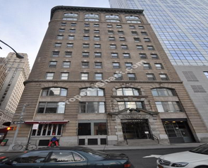

[**RW – warehouse/factory/industrial**](https://www.propertyshark.com/info/class-r-buildings-condominiums/#rw)

The RW building class designates commercial storage and industrial units in special condominium buildings. Units classified as RW are most frequent in Brooklyn (74% of city total) and Manhattan (24%).  
The neighborhoods with the most RW class units are Williamsburg and Gowanus in Brooklyn, NoMad, Chinatown and Gramercy Park in Manhattan.

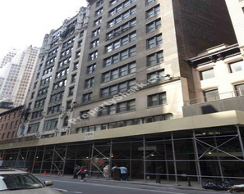

### Mixed Use

## Class S Buildings - Residence - Multiple Use

SOURCE: <https://www.propertyshark.com/info/class-s-buildings-residence-multiple-use/#s0>

[**S0 – primarily 1 family with 2 stores or offices**](https://www.propertyshark.com/info/class-s-buildings-residence-multiple-use/#s0)

The S0 building class comprises single-family homes that have two stores or offices. These homes are found most frequently in Brooklyn (43%) and Queens (25%).

The 5 neighborhoods with the biggest numbers of these homes are the Upper East Side / Carnegie Hill (Manhattan), Murray Hill (Manhattan), Sunset Park (Brooklyn), Westerleigh (Staten Island) and East New York (Brooklyn).

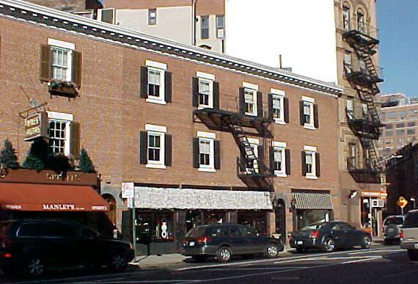

[**S1 – primarily 1 family with 1 store or office**](https://www.propertyshark.com/info/class-s-buildings-residence-multiple-use/#s1)

The S1 building class consists of single-family homes with a store or an office. They can be most frequently encountered in Brooklyn (47%) and Queens (32%) – more specifically, in the following Brooklyn neighborhoods: Bensonhurst West, Borough Park, Flatbush, Bay Ridge and Bensonhurst East.

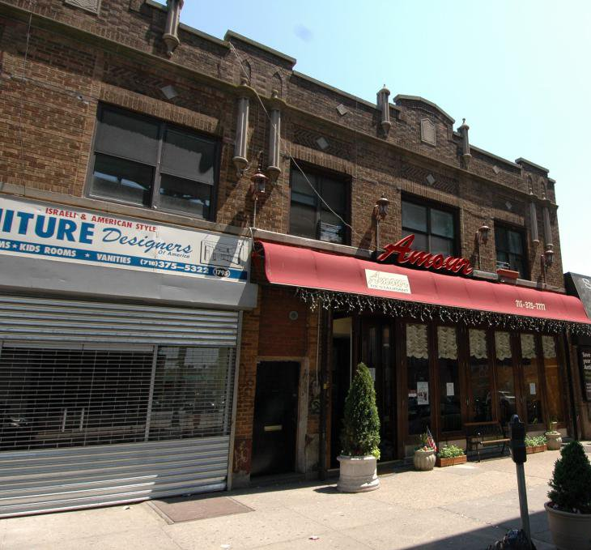

[**S2 – primarily 2 family with 1 store or office**](https://www.propertyshark.com/info/class-s-buildings-residence-multiple-use/#s2)

The S2 building class consists of two-family homes with a store or an office. They are the most numerous of all the S-class buildings, accounting for 44% of them. They can be found mostly in Brooklyn (59%) and Queens (30%).

The neighborhoods where they can be found most frequently are Bay Ridge (Brooklyn), Borough Park (Brooklyn), Flatbush (Brooklyn), Sunset Park (Brooklyn) and Ridgewood (Queens).

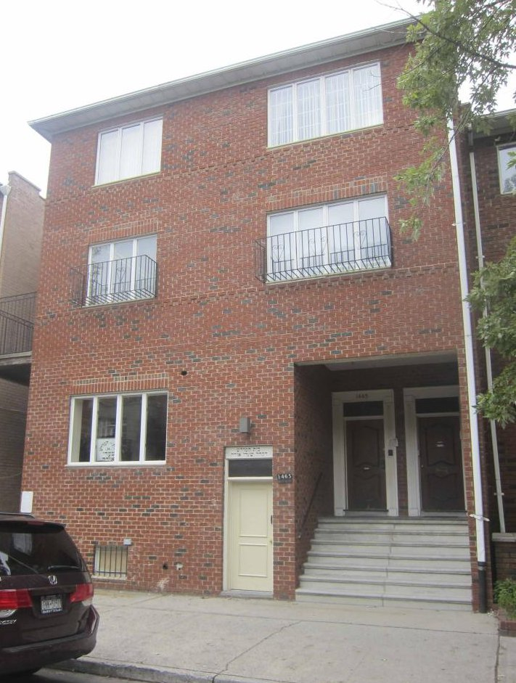

[**S3 – primarily 2 family with 1 store or office**](https://www.propertyshark.com/info/class-s-buildings-residence-multiple-use/#s3)

The S3 building class comprises three-family homes with a store or an office. Over half of them (52%) are in Brooklyn, followed by Queens (22%) and Manhattan (17%).

The top 5 neighborhoods where these buildings are the most frequently found are all in Brooklyn: North Side / South Side, Park Slope, Carroll Gardens / Columbia / Red Hook, Bedford and Crown Heights North.

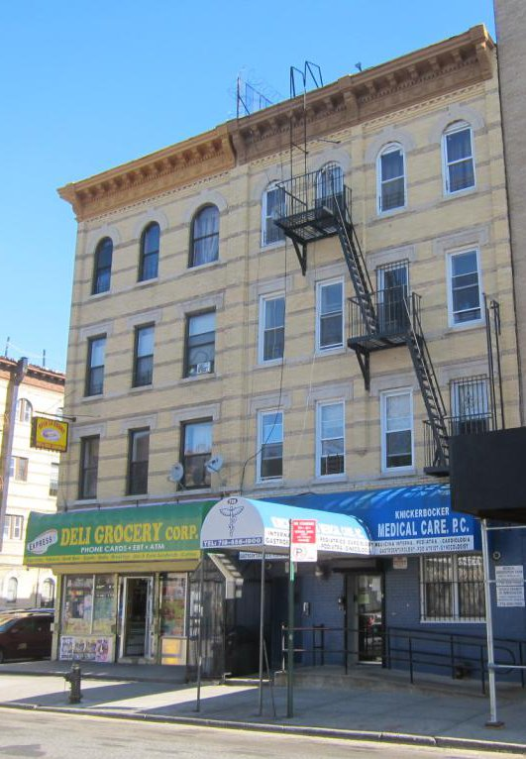

[**S4 – primarily 4 family with 1 store or office**](https://www.propertyshark.com/info/class-s-buildings-residence-multiple-use/#s4)

The S4 building class comprises four-family homes with a store or an office. Over half of them (55%) are in Brooklyn, with 25% in Queens and 15% in Manhattan.

The buildings in the S4 class are most frequently found in Bushwick North (Brooklyn), Bushwick South (Brooklyn), Sunset Park (Brooklyn), Ridgewood (Queens) and Crown Heights North (Brooklyn).

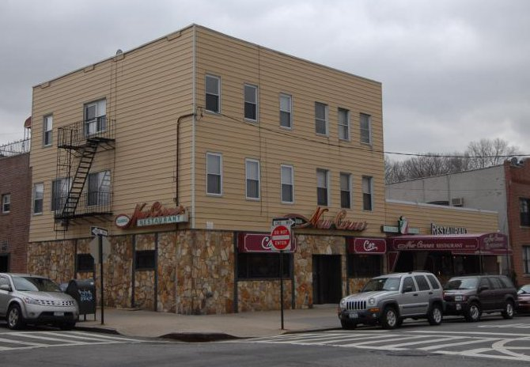

[**S5 – primarily 5-6 family with 1 store or office**](https://www.propertyshark.com/info/class-s-buildings-residence-multiple-use/#s5)

The S5 building class comprises properties with 5-6 families and a store or an office. As with all the other S-class buildings, most of them (58%) are in Brooklyn, which is followed by Manhattan (21%) and Queens (16%).

The neighborhoods with the biggest numbers of properties in the S5 class are Greenpoint (Brooklyn), Bushwick North (Brooklyn), Ridgewood (Queens), Bay Ridge (Brooklyn) and Sunset Park (Brooklyn).

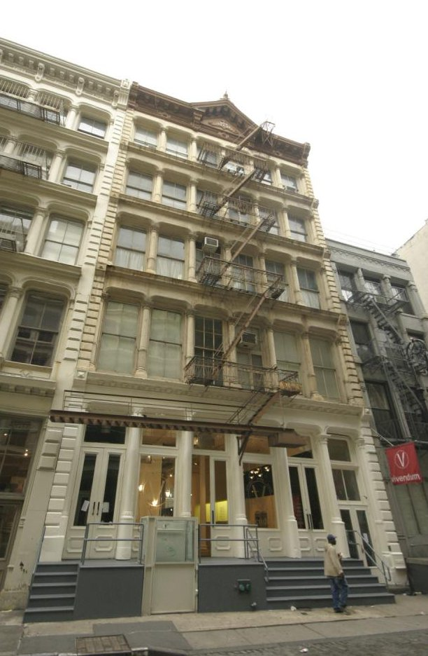

[**S9 – single or multiple dwelling with stores or offices**](https://www.propertyshark.com/info/class-s-buildings-residence-multiple-use/#s6)

The S9 building class is made up of 1- to 6-family homes with stores or offices. Over half of them (53%) are in Brooklyn, with 23% in Queens and 15% in Manhattan.

Properties in the S9 class are most frequently encountered in Sunset Park (Brooklyn), Ridgewood (Queens), Bushwick North (Brooklyn), Flatbush (Brooklyn) and Crown Heights North (Brooklyn).

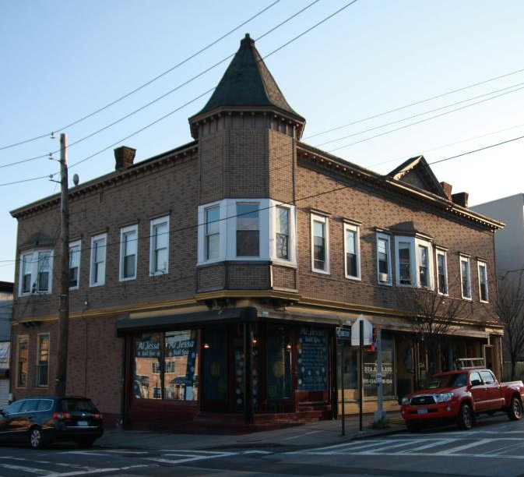

### Commercial Buildings

## Class H Buildings - Hotels

SOURCE: <https://www.propertyshark.com/info/class-h-buildings-hotels/#h1>

[**H1 – luxury hotel**](https://www.propertyshark.com/info/class-h-buildings-hotels/#h1)

The H1 building class consists of luxury hotels that were built prior to 1960. They are exclusive to Manhattan. The Radisson Lexington and The Carlyle are examples of hotels that fall under this category – they were the second and the third biggest hotel transactions in 2011.

These hotels can most frequently be encountered in Midtown / Midtown South, Turtle Bay / East Midtown, Murray Hill / Kips Bay, the Upper East Side / Carnegie Hill and Gramercy.

[**H2 – full service hotel**](https://www.propertyshark.com/info/class-h-buildings-hotels/#h2)

The H2 building class comprises luxury hotels that were built after 1960. Most of them are in Manhattan, but several can be also found in Queens, Brooklyn and Staten Island. One such hotel, the New York Palace, represented the biggest hotel transaction in 2011.

They can be found in the biggest numbers in Midtown / Midtown South, SoHo / Tribeca / Civic Central / Little Italy, Battery Park City / Lower Manhattan, Turtle Bay / East Midtown and Chinatown, all of which are in Manhattan.

[**H3 – limited service; many affiliated with national chain**](https://www.propertyshark.com/info/class-h-buildings-hotels/#h3)

The H3 building class comprises hotels with transient occupancy. They are most frequently found in Manhattan, but several can be found also in Brooklyn, the Bronx and Queens.

Top neighborhoods where these hotels can be found are Midtown / Midtown South, Murray Hill / Kips Bay, Hudson Yards / Chelsea / Flatiron / Union Square, Turtle Bay / East Midtown and Clinton, all in Manhattan.

[**H4 – motel**](https://www.propertyshark.com/info/class-h-buildings-hotels/#h4)

The H4 building class is represented by the motels in New York City. Most of them are in Queens, the Bronx and Brooklyn, but there are a few in Manhattan and Staten Island as well.

Motels are most frequent in Elmhurst / Maspeth (Queens), East New York (Brooklyn), Co-Op City (the Bronx), Eastchester / Edenwald / Baychester (the Bronx) and Clinton (Manhattan).

[**H5 – hotel; private club, luxury type**](https://www.propertyshark.com/info/class-h-buildings-hotels/#h5)

The H5 building class is made of private clubs and luxury-type hotels.

Almost all of them are located in Manhattan, especially in Upper East Side / Carnegie Hill and Midtown / Midtown South.

[**H6 – apartment hotel**](https://www.propertyshark.com/info/class-h-buildings-hotels/#h6)

The H6 building class comprises apartment hotels that are most often found in Manhattan, with a few in Brooklyn and the Bronx.

They can most frequently be found on the Upper West Side, and in Turtle Bay / East Midtown, Midtown / Midtown South, Lincoln Square and Clinton.

[**H7 – apartment hotel – cooperatively owned**](https://www.propertyshark.com/info/class-h-buildings-hotels/#h7)

The H7 building class is made up of hotels that are coop-owned. The units in these buildings are owned individually, but the buildings themselves operate as hotels.

There are only 3 of these buildings in New York City, all in Manhattan: 797 5th Avenue, 109 East 56th Street and 50 Gramercy Park North.

[**H8 – dormitory**](https://www.propertyshark.com/info/class-h-buildings-hotels/#h8)

The H8 building class comprises dormitories in NYC.

The vast majority of them can be found in Manhattan and Brooklyn. The neighborhoods where they are the most numerous are West Village (Manhattan), Morningside Heights (Manhattan), East Village (Manhattan), Brooklyn Heights (Brooklyn) and Murray Hill / Kips Bay (Manhattan).

[**H9 – miscellaneous hotel**](https://www.propertyshark.com/info/class-h-buildings-hotels/#h9)

The H9 building class is made up of various types of hotels that don’t fit into any of the other H-class buildings. They are actually the most numerous, accounting for approximately 40% of the total number of hotels. They are most frequent in Manhattan (55%), Queens (26%) and Brooklyn (12%).

The neighborhoods where they can be found most often are the Upper West Side (Manhattan), Hudson Yards / Chelsea / Flatiron / Union Square (Manhattan), Midtown / Midtown South (Manhattan), Queens Bridge / Ravenswood / Long Island City North (Queens) and Clinton (Manhattan).

[**HB – boutique: 10-100 rooms, w/luxury facilities, themed, stylish, w/full svc accommodations**](https://www.propertyshark.com/info/class-h-buildings-hotels/#hb)

The HB building class covers boutique luxury hotels. The majority of hotels in this buildings class are in Manhattan (84%), and they make up 4% of all buildings in the H general class.  
The neighborhoods where you can find the most HB class hotels are Murray Hill, SoHo, Central Midtown, the Theatre District and NoMad, all in Manhattan.

[**HH – hostels- bed rentals in dormitory-like settings w/shared rooms & bathrooms**](https://www.propertyshark.com/info/class-h-buildings-hotels/#hh)

The HH building class covers hostels and other dormitory-like rentals. The majority of buildings in this class are in Manhattan (89%), and they make up just 1% of all buildings in the H general class.  
The neighborhoods where you can find the most HB class hotels are the Upper West Side, the Theatre District, Chelsea, Manhattan Valley and NoLIta, all in Manhattan.

[**HR – sro- 1 or 2 people housed in individual rooms in multiple dwelling affordable housing**](https://www.propertyshark.com/info/class-h-buildings-hotels/#hr)

The HR building class designates rental buildings offering single-room occupancy units designed for low-income residents. The majority of buildings in this class are in Manhattan (63%), and 28% of them are in Brooklyn. These buildings make up 4% of all buildings in the H general class.  
The neighborhoods where you can find the most HR class hotels are the Upper West Side, Harlem, Lincoln Square and Chinatown in Manhattan, and Brighton Beach in Brooklyn.

[**HS – extended stay/suite: amenities similar to apt; typically charge weekly rates & less expensive than full-service hotel**](https://www.propertyshark.com/info/class-h-buildings-hotels/#hs)

The HS building class covers extended-stay hotels and other types of rentals similar to apartments, but not luxury or full-service hotels. Manhattan has most of the buildings in this class available in the city (93%), and Queens has 5%.  
The neighborhoods where you can find the most HS class buildings are Lenox Hill, Turtle Bay, Sutton Place, Manhattan Valley and the Upper West Side.

## Class K Buildings - Store Buildings (Taxpayers Included)

SOURCE: <https://www.propertyshark.com/info/class-k-buildings-store-buildings-taxpayers-included/#k1>

[**K1 – one story retail building**](https://www.propertyshark.com/info/class-k-buildings-store-buildings-taxpayers-included/#k1)

The K1 building class comprises one story store buildings.

They can most frequently be found in Queens, Brooklyn and the Bronx, in the following neighborhoods: Sheepshead Bay / Gerritsen Beach / Manhattan Beach (Brooklyn), Jamaica (Queens), Astoria (Queens), Flatbush (Brooklyn) and Brownsville (Brooklyn).

[**K2 – multi-story retail building (2 or more)**](https://www.propertyshark.com/info/class-k-buildings-store-buildings-taxpayers-included/#k2)

The K2 building class comprises two-story buildings or buildings with a store and an office that are most frequently found in Queens in Brooklyn.

The neighborhoods with the biggest numbers of these buildings are Flushing (Queens), Elmhurst (Queens), Borough Park (Brooklyn), Bensonhurst West (Brooklyn) and Jackson Heights (Queens).

[**K3 – multi-story department store**](https://www.propertyshark.com/info/class-k-buildings-store-buildings-taxpayers-included/#k3)

The K3 building class consists of multi-story department stores. From the total number of 61 buildings in the K3 class in New York City, 20 are in Manhattan, 16 in Brooklyn, 11 in Staten Island, 8 in the Bronx and 6 in Queens.

The neighborhoods that have the biggest numbers of these buildings are Bay Ridge (Brooklyn) with 10 and Midtown / Midtown South (Manhattan) with 7.

[**K4 – predominant retail with other uses**](https://www.propertyshark.com/info/class-k-buildings-store-buildings-taxpayers-included/#k4)

The K4 building class designates retail buildings that include units with other uses. They are most frequently found in Brooklyn (38% of city total), Queens (31%) and Manhattan (20%).  
The neighborhoods with the most K4 retail buildings are Borough Park, Williamsburg and Sunset Park in Brooklyn, Jamaica and South Astoria in Queens.

[**K5 – stand-alone food establishment**](https://www.propertyshark.com/info/class-k-buildings-store-buildings-taxpayers-included/#k5)

The K5 building class consists of diners.

They are most numerous in Queens, Brooklyn and Staten Island in the following neighborhoods: Great Kills (Staten Island), New Dorp / Midland Beach (Staten Island), East New York (Brooklyn), South Beach / Old Town / Dongan Hills (Staten Island) and New Brighton, Silver Lake (Staten Island).

[**K6 – shopping center with or without parking**](https://www.propertyshark.com/info/class-k-buildings-store-buildings-taxpayers-included/#k6)

The K6 building class comprises shopping centers that have parking facilities.

They are most frequently encountered in Staten Island and Queens, in the following neighborhoods: Charleston / Richmond Valley / Tottenville (Staten Island), New Springville / Bloomfield / Travis (Staten Island), Great Kills (Staten Island), Whitestone (Queens) and TodtHill / Emerson Hill / Heartland Village / Lighthouse Hill (Staten Island).

[**K7 – banking facilities with or without parking**](https://www.propertyshark.com/info/class-k-buildings-store-buildings-taxpayers-included/#k7)

The K7 building class is made up of funeral homes. They are most numerous in Brooklyn (34%) and Queens (31%), followed by the Bronx (15%), Manhatann (12%) and Staten Island (8%).

The neighborhoods with the biggest numbers of funeral homes are Clinton Hill (Brooklyn), East New York (Brooklyn), Forest Hills (Queens), Schuylerville / Throgs Neck / Edgwater Park (the Bronx) and Central Harlem North (Manhattan).

[**K9 – miscellaneous store building**](https://www.propertyshark.com/info/class-k-buildings-store-buildings-taxpayers-included/#k9)

The K9 building class comprises miscellaneous store buildings.

They are most numerous in Brooklyn (34%), Manhattan (33%) and Queens (25%), in the following neighborhoods: Midtown / Midtown South (Manhattan), SoHo / Tribeca / Civic Central / Little Italy (Manhattan), Chinatown (Manhattan), Flushing (Queens) and Astoria (Queens).

## Class L Buildings - Loft Buildings

SOURCE: <https://www.propertyshark.com/info/class-l-buildings-loft-buildings/#l1>

[**L1 – loft; over 8 stories (mid manh. type)**](https://www.propertyshark.com/info/class-l-buildings-loft-buildings/#l1")

Buildings in the L1 class are loft buildings that are over 8 stories high, primarily found in Manhattan (99%).

They can be both with or without stores. The great majority of them can be found in Midtown / Midtown South and Hudson Yards / Chelsea / Flatiron / Union Square.

[**L2 – loft; fireproof and storage type without stores**](https://www.propertyshark.com/info/class-l-buildings-loft-buildings/#l2)

The L2 class consists of fireproof loft and storage-type buildings that don’t have retail stores.

Most of them can be found in Manhattan (72%) and Brooklyn (17%). Moreover, about 63% of them are in Hudson Yards / Chelsea / Flatiron / Union Square.

[**L3 – loft; semi-fireproof**](https://www.propertyshark.com/info/class-l-buildings-loft-buildings/#l3)

The L3 building class consists of semi-fireproof loft buildings. The L3 class is not very numerous. From the 33 buildings in the class, 23 are in Manhattan and 10 in Brooklyn.

The neighborhoods where they can be found most often are SoHo / Tribeca / Civic Central / Little Italy, Hudson Yards / Chelsea / Flatiron / Union Square and West Village.

[**L8 – loft; with retail stores other than type one**](https://www.propertyshark.com/info/class-l-buildings-loft-buildings/#l8)

The L8 building class contains loft buildings with retail stores. They are the most numerous among all L-class buildings and most of them are located in Manhattan (92%).

Most of these buildings can be found in the following Manhattan neighborhoods: Midtown / Midtown South, Hudson Yards / Chelsea / Flatiron / Union Square, SoHo / Tribeca / Civic Central / Little Italy, Chinatown and East Harlem North.

[**L9 – miscellaneous loft**](https://www.propertyshark.com/info/class-l-buildings-loft-buildings/#l9)

The L9 building class comprises miscellaneous loft buildings. The great majority of them can be found in Manhattan (62%) and Brooklyn (36%), in the following neighborhoods: SoHo / Tribeca / Civic Central / Little Italy (Manhattan), Hudson Yards / Chelsea / Flatiron / Union Square (Manhattan), North Side / South Side (Brooklyn), West Village (Manhattan) and Greenpoint (Brooklyn).

## Class O Buildings - Office Buildings

SOURCE: <https://www.propertyshark.com/info/class-o-buildings-office-buildings/#o1>

[**O1 – office only – 1 story**](https://www.propertyshark.com/info/class-o-buildings-office-buildings/#o1)

The O1 building class comprises fireproof office buildings that are up to 9 stories high. Most of them are in Queens (35%) and Manhattan (34%). The rest of them are spread relatively evenly in the other 3 boroughs.

They are most commonly found in Midtown / Midtown South (Manhattan), Dumbo / Vinegar Hill / Downtown Brooklyn / Boerum Hill (Brooklyn), the Upper East Side / Carnegie Hill (Manhattan), Flushing (Queens) and Battery Park City / Lower Manhattan (Manhattan).

[**O2 – office only 2 – 6 stories**](https://www.propertyshark.com/info/class-o-buildings-office-buildings/#o2)

The O2 building class consists of office buildings that are ten stories high or higher and are not on the main streets. The great majority of them can be found in Manhattan and about a dozen of them in total can be found in Queens, Brooklyn and the Bronx.

The neighborhoods where these buildings are the most numerous are Midtown / Midtown South, Hudson Yards / Chelsea / Flatiron / Union Square, Murray Hill / Kips Bay, Turtle Bay / East Midtown and Gramercy, all of them in Manhattan.

[**O3 – office only 7 – 19 stories**](https://www.propertyshark.com/info/class-o-buildings-office-buildings/#o3)

The O3 building class consists of office buildings that are ten stories high or higher and are on main avenues. Most of them are in Manhattan but there are several of them also in Brooklyn, Queens and the Bronx.

The top 5 neighborhoods where the O3 office buildings can be found in the biggest numbers are Midtown / Midtown South, Battery Park City / Lower Manhattan, Hudson Yards / Chelsea / Flatiron / Union Square, Turtle Bay / East Midtown and Murray Hill / Kips Bay, all in Manhattan.

[**O4 – office only with or without comm – 20 stories or more**](https://www.propertyshark.com/info/class-o-buildings-office-buildings/#o4)

The O4 property class consists of tower-type office buildings that are specific to Manhattan. Most of these buildings are 20 stories high or higher.

They can mostly be found in Midtown / Midtown South, Turtle Bay / East Midtown, Battery Park City / Lower Manhattan, Murray Hill / Kips Bay and SoHo / Tribeca / Civic Central / Little Italy.

[**O5 – office with comm – 1 to 6 stories**](https://www.propertyshark.com/info/class-o-buildings-office-buildings/#o5)

The O5 property class comprises semi-fireproof office buildings which can most frequently be found in Manhattan, Staten Island and Queens.

The neighborhoods where these buildings are most numerous are New Dorp / Midland Beach (Staten Island), Midtown / Midtown South (Manhattan), Hudson Yards / Chelsea / Flatiron / Union Square (Manhattan), SoHo / Tribeca / Civic Central / Little Italy (Manhattan), Jamaica (Queens) and South Beach / Old Town / Dongan Hills (Staten Island).

[**O6 – office with comm 7 – 19 stories**](https://www.propertyshark.com/info/class-o-buildings-office-buildings/#o6)

Buildings in the O6 class are bank buildings that are designed exclusively for banking.

They are most frequently found in Queens and Brooklyn, in the following neighborhoods: Bay Ridge (Brooklyn), Bensonhurst West (Brooklyn), Jamaica (Queens), Borough Park (Brooklyn), Upper East Side / Carnegie Hill (Manhattan) and South Ozone Park (Queens).

[**O7 – professional buildings/stand alone funeral homes**](https://www.propertyshark.com/info/class-o-buildings-office-buildings/#o7)

The O7 building class consists of office buildings for various professionals. They are most numerous in Brooklyn (37%), Staten Island (24%) and Queens (22%).

The neighborhoods with the biggest numbers of buildings in the O7 class are: Sheepshead Bay / Gerritsen Beach / Manhattan Beach (Brooklyn), Westerleigh (Staten Island), South Beach / Old Town / Dongan Hills (Staten Island), Bay Ridge (Brooklyn), Great Kills (Staten Island) and Homecrest (Brooklyn).

[**O8 – office with apartments only (no comm)**](https://www.propertyshark.com/info/class-o-buildings-office-buildings/#o8)

The O8 building class consists of office buildings with residential apartments. Most of these buildings can be found in Brooklyn (34%), Queens (31%) and Staten Island (20%).

The neighborhoods with the biggest numbers of these buildings are Bay Ridge (Brooklyn), Westerleigh (Staten Island), Flatlands (Brooklyn), Madison (Manhattan) and Brighton Beach (Brooklyn).

[**O9 – miscellaneous and old style bank bldgs.**](https://www.propertyshark.com/info/class-o-buildings-office-buildings/#o9)

The O9 building class consists of miscellaneous office buildings most commonly found in Manhattan (32%), Queens (28%) and Brooklyn (25%).

The neighborhoods where they are the most numerous are SoHo / Tribeca / Civic Central / Little Italy (Manhattan), Midtown / Midtown South (Manhattan), Hudson Yards / Chelsea / Flatiron / Union Square (Manhattan), Hunters Point / Sunnyside / West Maspeth (Queens) and Borough Park (Brooklyn).

### Industrial Buildings

## Class E Buildings - Warehouses

SOURCE: <https://www.propertyshark.com/info/class-e-buildings-warehouses/#e1>

[**E1 – Fireproof Warehouse**](https://www.propertyshark.com/info/class-e-buildings-warehouses/#e1)

The E1 building class comprises fireproof warehouses. Most of these warehouses can be found in Queens (46%), Brooklyn (30%) and the Bronx (17%).

The neighborhoods with the biggest numbers of fireproof warehouses are Hunters Point / Sunnyside / West Maspeth (Queens), South Brookville / Springfield / Gardens (Queens), East New York (Brooklyn), Maspeth (Queens) and Hunts Point (the Bronx).

[**E3 – Semi-Fireproof Warehouse**](https://www.propertyshark.com/info/class-e-buildings-warehouses/#e3)

The E3 building class consists of semi-fireproof warehouses. Most of these warehouses are found in Brooklyn (46%) and Queens (40%).

Here are the top 5 neighborhoods where semi-fireproof warehouses can be found in the biggest numbers: Sunset Park (Brooklyn), Hunters Point / Sunnyside / West Maspeth (Queens), Greenwood Heights (Brooklyn), Woodside (Queens) and Hunts Point (the Bronx).

[**E4 – Metal Frame Warehouse**](https://www.propertyshark.com/info/class-e-buildings-warehouses/#e4)

The E4 building class consists of warehouses made of metal or with a frame structure. They can be found mostly in Queens (31%), Brooklyn (30%), Staten Island (22%) and the Bronx (17%).

Here are the top 5 neighborhoods with the biggest numbers of frame/metal warehouses: Stapleton / Rosebank (Staten Island), Hunts Point (the Bronx), Jamaica (Queens), Charleston / Richmond Valley / Tottenville (Staten Island) and Hunters Point / Sunnyside / West Maspeth (Queens).

[**E7 – Self Storage Warehouse**](https://www.propertyshark.com/info/class-e-buildings-warehouses/#e7)

The E7 building class is made up of self storage warehouses. They can be found in all 5 boroughs, as follows: Brooklyn (28%), Queens (24%), Manhattan (23%), the Bronx (19%) and Staten Island (6%).

The neighborhoods where these warehouses can be found in the biggest numbers are Hunters Point / Sunnyside / West Maspeth (Queens), East New York (Brooklyn), Hudson Yards / Chelsea / Flatiron / Union Square (Manhattan), Manhattanville (Manhattan) and East Harlem North (Manhattan).

[**E9 – Miscellaneous Warehouse**](https://www.propertyshark.com/info/class-e-buildings-warehouses/#e9)

The E9 building class comprises miscellaneous warehouses. Over half of them (53%) are in Brooklyn and over a quarter of them (26%) in Queens.

The top 5 neighborhoods with the biggest numbers of warehouses in the E9 class are Hunters Point / Sunnyside / West Maspeth (Queens), Carroll Gardens / Columbia / RedHook (Brooklyn), Sunset Park (Brooklyn), East Williamsburg (Brooklyn) and North Side / South Side (Brooklyn).

## Class F Buildings - Factory And Industrial Buildings

SOURCE: <https://www.propertyshark.com/info/class-f-buildings-factory-industrial-buildings/#f1>

[**F1 – Factory; Heavy Manufacturing (Fireproof)**](https://www.propertyshark.com/info/class-f-buildings-factory-industrial-buildings/#f1)

The F1 property class comprises fireproof factory and industrial buildings that are involved in heavy manufacturing. Most of them can be found in Queens (54%), Brooklyn (27%) and the Bronx (17%).

The top neighborhoods with factories and industrial buildings in the F1 class are Hunters Point / Sunnyside / West Maspeth (Queens), Queens Bridge / Ravenswood / Long Island City North (Queens), East New York (Brooklyn), Hunts Point (the Bronx) and Woodside (Queens).

[**F2 – Factory; Special Construction – Fireproof**](https://www.propertyshark.com/info/class-f-buildings-factory-industrial-buildings/#f2)

The F2 building class comprises special constructions like printing plants that are fireproof. They can mostly be found in Brooklyn (38%), Queens (32%) and the Bronx (18%).

The neighborhoods that have this type of buildings in the biggest numbers are Hunters Point / Sunnyside / West Maspeth (Queens), Bedford (Brooklyn), East New York (Brooklyn), Hunts Point (the Bronx) and Jamaica (Queens).

[**F4 – Factory; Industrial Semi-Fireproof**](https://www.propertyshark.com/info/class-f-buildings-factory-industrial-buildings/#f4)

Semi-fireproof factory and industrial buildings are part of the F4 building class. Most of these buildings can be found in Queens (50%), Brooklyn (36%) and the Bronx (14%).

The following neighborhoods have the biggest numbers of semi-fireproof factories and industrial buildings: Hunters Point / Sunnyside / West Maspeth (Queens), Hunts Point (the Bronx), Queens Bridge / Ravenswood / Long Island City North (Queens), College Point (Queens) and East Williamsburg (Brooklyn).

[**F5 – Factory; Light Manufacturing**](https://www.propertyshark.com/info/class-f-buildings-factory-industrial-buildings/#f5)

Light manufacturing factories are part of the F5 building class. The majority of them can be found in Brooklyn (55%), Queens (20%) and the Bronx (16%).

The top neighborhoods with the biggest numbers of these factories are Sunset Park (Brooklyn), Greenwood Heights (Brooklyn), North Side / South Side (Brooklyn), Borough Park (Brooklyn) and Stapleton / Rosebank (Staten Island).

[**F8 – Factory; Tank Farms**](https://www.propertyshark.com/info/class-f-buildings-factory-industrial-buildings/#f8)

Tank farms form the F8 building class. Most of them are in Brooklyn and the Bronx, in the following neighborhoods: Greenpoint (Brooklyn), Hunts Point (the Bronx), Westchester / Unionport (the Bronx) and Carroll Gardens / Columbia / Red Hook (Brooklyn).

[**F9 – Factory; Industrial – Miscellaneous**](https://www.propertyshark.com/info/class-f-buildings-factory-industrial-buildings/#f9)

The F9 building class comprises miscellaneous factories and industrial buildings. They can mostly be found in Brooklyn (55%), Queens (32%) and the Bronx (10%).

The neighborhoods where these buildings can be found in the biggest numbers are Hunters Point / Sunnyside / West Maspeth (Queens), Queens Bridge, Ravenswood, Long Island City North (Queens), Greenpoint (Brooklyn), Carroll Gardens / Columbia / Red Hook (Brooklyn) and Gowanus (Brooklyn).

## Class G Buildings - Garages and Gasoline Stations

SOURCE: <https://www.propertyshark.com/info/class-g-buildings-garages-gasoline-stations/#g0>

[**G0 – garage; residential tax class 1**](https://www.propertyshark.com/info/class-g-buildings-garages-gasoline-stations/#g0)

The G0 building class consists of garages in the residential tax class 1. They can be found in the greatest numbers in Queens (44%), Brooklyn (24%) and the Bronx (21%).

The neighborhoods with the biggest numbers of garages in the G0 class are Sheepshead Bay / Gerritsen Beach / Manhattan Beach (Brooklyn), Forest Hills (Queens), Williamsbridge / Olinville (the Bronx), Schuylerville / Throgs Neck / Edgwater Park (the Bronx) and Woodlawn / Wakefield (the Bronx).

[**G1 – all parking garages**](https://www.propertyshark.com/info/class-g-buildings-garages-gasoline-stations/#g1)

The G1 building class consists of garages in buildings that are two or more stories high. Unsurprisingly, Manhattan has the highest number of garages in this class, representing 46% of the total. It is followed by the Bronx (22%) and Brooklyn (18%).

The neighborhoods where these garages can be found in the biggest numbers are Midtown / Midtown South, Hudson Yards / Chelsea / Flatiron / Union Square, the Upper West Side, West Village and SoHo / Tribeca / Civic Central / Little Italy, all in Manhattan.

[**G2 – auto body/collision or auto repair**](https://www.propertyshark.com/info/class-g-buildings-garages-gasoline-stations/#g2)

The G2 building class comprises fireproof or semi-fireproof garages in one-story buildings. Garages in this class can mostly be found in Brooklyn (38%), Queens (35%) and the Bronx (16%).

The top neighborhoods with the biggest numbers of garages in the G2 class are Hunters Point / Sunnyside / West Maspeth (Queens), Jamaica (Queens), East New York (Brooklyn), Woodside (Queens) and Seagate / Coney Island (Brooklyn).

[**G3 – gas station with retail store**](https://www.propertyshark.com/info/class-g-buildings-garages-gasoline-stations/#g3)

The G3 building class consists of gas stations with garages. The majority of them are in Queens (52%) and Brooklyn (32%) and they can be found in neighborhoods like Sunset Park (Brooklyn), Crown Heights North (Brooklyn), South Ozone Park (Queens), Midwood (Brooklyn), Corona (Queens), Woodhaven (Queens), etc.

[**G4 – gas station with service/auto repair**](https://www.propertyshark.com/info/class-g-buildings-garages-gasoline-stations/#g4)

The G4 building class comprises gas stations with enclosed lubrication plants or workshops. Most of them can be found in Queens (41%), Brooklyn (34%) and the Bronx (14%).

The neighborhoods where the biggest numbers of these gas stations can be found are East New York (Brooklyn), Flatlands (Brooklyn), Hunters Point / Sunnyside / West Maspeth (Queens), Sunset Park (Brooklyn) and Canarsie (Brooklyn).

[**G5 – gas station only with/without small kiosk**](https://www.propertyshark.com/info/class-g-buildings-garages-gasoline-stations/#g5)

The G5 building class consists of gas stations without enclosed lubrication plants or workshops. Brooklyn has the greatest number of these gas stations (30%), followed Queens (29%) and the Bronx (25%).

The neighborhoods with the biggest numbers of gas stations in the G5 class are Hunters Point / Sunnyside / West Maspeth (Queens), Crown Heights North (Brooklyn), Jackson Heights (Queens), Mott Haven, Port Morris (the Bronx) and Flatbush (Brooklyn).

[**G6 – licensed parking lot**](https://www.propertyshark.com/info/class-g-buildings-garages-gasoline-stations/#g6)

The G6 building class comprises licensed parking lots. Manhattan has the biggest numbers of these parking lots (32%), followed by Brooklyn (25%), the Bronx (24%) and Queens (18%).

The neighborhoods where licensed parking lots can be found in the biggest numbers are Hudson Yards / Chelsea / Flatiron / Union Square, Hudson Yards / Chelsea / Flatiron / Union Square, SoHo / Tribeca / Civic Central / Little Italy, Midtown / Midtown South and Clinton, all in Manhattan.

[**G7 – unlicensed parking lot**](https://www.propertyshark.com/info/class-g-buildings-garages-gasoline-stations/#g7)

The G7 building class consists of unlicensed parking lots in New York City. Most of them can be found in Brooklyn (43%), Queens (29%) and the Bronx (18%).

Here are the top neighborhoods with the biggest numbers of unlicensed parking lots: Bushwick South (Brooklyn), East New York (Brooklyn), North Side / South Side (Brooklyn), Bedford (Brooklyn) and Hunters Point / Sunnyside / West Maspeth (Queens).

[**G8 – car sales/rental with showroom**](https://www.propertyshark.com/info/class-g-buildings-garages-gasoline-stations/#g8)

Garages with showrooms in New Your City are part of the G8 building class. From the total number of these garages, 41% are in Queens, 25% are in Brooklyn, 13% in the Bronx, 11% in Manhattan and 10% in Staten Island.

Here are the top neighborhoods with the biggest numbers of garages with showrooms: Clinton (Manhattan), Bayside / Bayside Hills (Queens), South Beach / Old Town / Dongan Hills (Staten Island), Briarwood / Jamaica Hill (Queens) and Bay Ridge (Brooklyn).

[**G9 – miscellaneous garage or gas station**](https://www.propertyshark.com/info/class-g-buildings-garages-gasoline-stations/#g9)

The G9 building class comprises miscellaneous garage buildings. They are most numerous in Brooklyn (39%), Queens (31%) and the Bronx (19%).

The top 5 neighborhoods with the biggest numbers of these buildings are Queens Bridge / Ravenswood / Long Island City North (Queens), East New York (Brooklyn), Hunters Point / Sunnyside / West Maspeth (Queens), Hunts Point (the Bronx) and Sunset Park (Brooklyn).

## Class T Buildings - Transportation Facilities (Assessed In Ore)

SOURCE: <https://www.propertyshark.com/info/class-t-buildings-transportation-facilities-assessed-ore/#t1>

[**T1 – Airports, Air Fields, Terminals**](https://www.propertyshark.com/info/class-t-buildings-transportation-facilities-assessed-ore/#t1)

New York City airports, air fields and terminals are all part of the T1 building class.

John F. Kennedy International Airport and La Guardia Airport are both part of the T1 building class.

[**T2 – Piers, Docks, Bulkheads**](https://www.propertyshark.com/info/class-t-buildings-transportation-facilities-assessed-ore/#t2)

Piers, docks and bulkheads in New York City are all part of the T2 building class.

They are most numerous in Manhattan, more specifically in Hudson Yards / Chelsea, Flatiron / Union Square, East Harlem North and Lenox Hill.

[**T9 – Miscellaneous**](https://www.propertyshark.com/info/class-t-buildings-transportation-facilities-assessed-ore/#t9)

The T9 building class includes miscellaneous transportation facilities in New York City.

They are most numerous in Manhattan, Brooklyn, Queens and Staten Island, more specifically in the following neighborhoods: the Lower East Side (Manhattan), Sunset Park (Brooklyn), North Side / South Side (Brooklyn) and Mariner’s Harbor / Arlington / Port Ivory / Graniteville (Staten Island

## Class U Buildings - Utility Bureau Properties

SOURCE: <https://www.propertyshark.com/info/class-u-buildings-utility-bureau-properties/#u0>

[**U0 – utility company land and building**](https://www.propertyshark.com/info/class-u-buildings-utility-bureau-properties/#u0)

The U0 building class comprises utility company lands and buildings. There are not many buildings in this class in New York City. They are most numerous in Manhattan (15). The Manhattan’s Battery park City / Lower Manhattan and Staten Island’s New Springville / Bloomfield / Travis are the neighborhoods with the biggest numbers of these buildings.

[**U1 – bridge, tunnel, highway**](https://www.propertyshark.com/info/class-u-buildings-utility-bureau-properties/#u1)

The U1 Building Class is part of the Utility Bureau Properties class. It includes bridges, tunnels, and highways. Most of these properties are owned by the Port of NY Authority, the New York City Department of Transportation or the MTA. There are over 2000 bridges and tunnels all across the 5 boroughs, most of them over the East River and the Harlem River. Most trafficked bridge in New York City is the Queensboro Bridge.

[**U2 – gas or electric utility**](https://www.propertyshark.com/info/class-u-buildings-utility-bureau-properties/#u2)

The U2 building class comprises electric and gas utility properties. 38% of these properties are in Staten Island, 29% in Queens, 16% in Brooklyn, 9% in Manhattan and 8% in the Bronx.

The top neighborhoods with the biggest numbers of these buildings are New Springville / Bloomfield / Travis (Staten Island), Stapleton / Rosebank (Staten Island), Dumbo / Vinegar Hill / Downtown Brooklyn / Boerum Hill (Brooklyn), Mariner’s Harbor / Arlington / Port Ivory / Graniteville (Staten Island) and Todt Hill / EmersonHill / Heartland Village / Lighthouse Hill (Staten Island).

[**U4 – telephone utility**](https://www.propertyshark.com/info/class-u-buildings-utility-bureau-properties/#u4)

Telephone utility buildings in New York City are part of the U4 building class. Most of them can be found in Queens (27%), Manhattan (26%), Brooklyn (20%) and the Bronx (19%).

The neighborhoods with the biggest numbers of these buildings are Clinton (Manhattan), Dumbo / Vinegar Hill / Downtown Brooklyn / Boerum Hill (Brooklyn), Washington Heights North (Manhattan) and East New York (Brooklyn).

[**U5 – communication facility other than telephone**](https://www.propertyshark.com/info/class-u-buildings-utility-bureau-properties/#u5)

The U5 building class comprises communication facilities other than telephones. There are 16 of these properties in New York City, 10 of which are in Brooklyn, 3 in Staten Island, 2 in the Bronx and 1 in Queens.

These are facilities that aid satellite service providers, cable service providers, etc.

[**U6 – railroad – private ownership**](https://www.propertyshark.com/info/class-u-buildings-utility-bureau-properties/#u6)

Private ownership railroad properties are part of the U6 building class. 33% of these buildings are in Staten Island, 20% in the Bronx, 18% in Manhattan, 15% in Queens and 14% in Brooklyn.

The neighborhoods where they can be found in the biggest numbers are Mariner’s Harbor / Arlington / Port Ivory / Graniteville (Staten Island), Hudson Yards / Chelsea / Flatiron / Union Square (Manhattan), Bensonhurst East (Brooklyn), Stapleton / Rosebank (Staten Island) and Charleston / Richmond Valley / Tottenville (Staten Island).

[**U7 – transportation – public ownership**](https://www.propertyshark.com/info/class-u-buildings-utility-bureau-properties/#u7)

The U7 building class is the most commonly found of all the classes in this group. It consists of public ownership transportation utilty properties. The majoroty of these buildings can be found in Queens (44%) and Brooklyn (36%).

The top 5 neighborhoods with the biggest numbers of these buildings are Bensonhurst West (Brooklyn), Flatbush (Brooklyn), Hunters Point / Sunnyside / West Maspeth (Queens), Hammels / Arverne / Edgemere (Queens) and Windsor Terrace (Brooklyn).

[**U8 – revocable consent**](https://www.propertyshark.com/info/class-u-buildings-utility-bureau-properties/#u8)

The U8 building classcomprises buildings that have been granted revocable consent approvals. A revocable consent allows a building’s owner to construct over, under or on the city property. In New York City, 42% of these buildings are in Brooklyn, 23% in the Bronx and 18% in Queens.

The neighborhoods where these buildings can be found in the biggest numbers are Sunset Park (Brooklyn), Murray Hill (Manhattan), Hunts Point (the Bronx), Prospect / Lefferts Gardens / Wingate (Brooklyn), Charleston / Richmond Valley / Tottenville (Staten Island) and Sheepshead Bay / Gerritsen Beach / Manhattan Beach (Brooklyn).

[**U9 – miscellaneous utility property**](https://www.propertyshark.com/info/class-u-buildings-utility-bureau-properties/#u9)

The U9 building class includes miscellaneous buildings like private improvements on city lands and in public places. 27% of these buildings are in Staten Island, 25% in Queens, 25% in Brooklyn and 18% in the Bronx.

The neighborhoods where these buildings can be found in the greatest numbers are East New York (Brooklyn), New Dorp / Midland Beach (Staten Island), Port Richmond (Staten Island), New Springville / Bloomfield / Travis (Staten Island) and Highbridge (the Bronx).

### Vacant Lots

## Class V Buildings - Vacant Land

SOURCE: <https://www.propertyshark.com/info/class-v-buildings-vacant-land/#v0>

[**V0 – zoned residential; not manhattan**](https://www.propertyshark.com/info/class-v-buildings-vacant-land/#v0)

The V0 building class comprises vacant lots in residential zones, except Manhattan below 110th Street. Staten Island, with 33%, and Queens, with 31%, have the biggest shares of vacant lands in the V0 class. They are followed by Brooklyn (21%) and the Bronx (15%). Manhattan doesn’t have any properties in the V0 building class. This class has more vacant lots than any other, and accounts for 72% of V-class properties.

The neighborhoods with the biggest numbers of vacant lots in the V0 class are Eltingville / Annadale / Huguenot / Blue Heron Park / Wolfe’s Pond Park / Mount Loretto (Staten Island), South Beach / Old Town / Dongan Hills (Staten Island), Charleston / Richmond Valley / Tottenville (Staten Island), Hammels / Arverne / Edgemere (Queens) and East New York (Brooklyn).

[**V1 – zoned commercial or manhattan residential**](https://www.propertyshark.com/info/class-v-buildings-vacant-land/#v1)

The V1 building class consists of vacant lots in non-residential zones, including Manhattan below 110th Street. Vacant lands in this class are the second most numerous among all V-class properties. Brooklyn has 35% of these properties, followed by Queens (19%) and Manhattan (18%).

The neighborhoods with the biggest numbers of vacant lots in the V1 class are Charleston / Richmond Valley / Tottenville (Staten Island), Hunters Point / Sunnyside / West Maspeth (Queens), Bedford (Brooklyn), East Harlem North (Manhattan) and Ocean Hill (Brooklyn).

[**V2 – zoned commercial adjacent to class 1 dwelling: not manhattan**](https://www.propertyshark.com/info/class-v-buildings-vacant-land/#v2)

The V2 building class comprises vacant lands in areas that are adjacent to tax class 1 dwellings. 36% of them are in Brooklyn, 33% in Queens, 16% in Staten Island and 15% in the Bronx. There are no vacant lots in the V2 class in Manhattan.

The neighborhoods where these vacant lots are the most numerous are Schuylerville / Throgs Neck / Edgwater Park (the Bronx), Sheepshead Bay / Gerritsen Beach / Manhattan Beach (Brooklyn), East New York (Brooklyn) and Richmond Hill (Queens).

[**V3 – zoned primarily residential; not manhattan**](https://www.propertyshark.com/info/class-v-buildings-vacant-land/#v3)

The V3 building class consists primarily of vacant lots that are in residential areas. 44% of them are in Brooklyn, 23% in Queens, 20% in Staten Island and 13% in the Bronx. There are no properties in the V3 class in Manhattan.

The neighborhoods with the biggest numbers of vacant lots in the V3 class are Great Kills (Staten Island), Crown Heights North (Brooklyn), Stapleton / Rosebank (Staten Island), Charleston / Richmond Valley / Tottenville (Staten Island), Hammels / Arverne / Edgemere (Queens) and Park Slope (Brooklyn).

[**V4 – police or fire department**](https://www.propertyshark.com/info/class-v-buildings-vacant-land/#v4)

The V4 building class consists of vacant lots that are adjacent to Police Departments or Fire Departments.

There are 18 properties in the V4 class in New York City. 6 are in the Bronx (all in Hunts Point), 4 are in Manhattan (all in Central Harlem North), 4 are in Brooklyn (3 in Sunset Park and 1 in Sea Gate / Coney Island), and finally, 4 are in in Queens (one in each of Hammels / Arverne / Edgemere, College Point, Forest Hills and Richmond Hill).

[**V5 – school site or yard**](https://www.propertyshark.com/info/class-v-buildings-vacant-land/#v5)

Vacant lots that are adjacent to schools or yards are all part of the V5 building class. Out of the total number of 35 properties in the V5 class, 20 are in Manhattan, 8 in Brooklyn, 3 in both Queens and the Bronx, and 1 is in Staten Island.

The neighborhoods with the biggest numbers of vacant lots in the V5 class are Manhattanville (Manhattan), East Harlem South (Manhattan), Gravesend (Brooklyn), East Village (Manhattan), Parkchester (the Bronx) and Kensington / Ocean Parkway (Brooklyn).

[**V6 – library, hospital or museum**](https://www.propertyshark.com/info/class-v-buildings-vacant-land/#v6)

The V6 building class comprises vacant lots that are adjacent to libraries, hospitals or museums. There are 11 of this type of property in New York City, 5 in Manhattan, 2 in both Queens and the Bronx, and 1 in both Brooklyn and Staten Island.

Inwood (Manhattan) with 4 and Pelham Parkway (the Bronx) with 2 are the only neighborhoods that have more than 1 vacant lot in the V6 class.

[**V7 – port authority of new york and new jersey**](https://www.propertyshark.com/info/class-v-buildings-vacant-land/#v7)

The V7 building class comprises vacant lots that belong to the Port Authority of New York and New Jersey, the bi-state authority that is in charge of most transportation facilities that are part of the Port of New York and New Jersey.

Most of these properties are in Staten Island (68%) and Manhattan (18%). The neighborhoods that have the biggest numbers of vacant lots in the V7 class are New Springville / Bloomfield / Travis and Mariners Harbor / Arlington / Port Ivory / Graniteville, both in Staten Island.

[**V8 – new york state or us government**](https://www.propertyshark.com/info/class-v-buildings-vacant-land/#v8)

The V8 building class consists of vacant lots owned by the State of New York or the U.S. Government. The majority of these vacant lands are in Staten Island (76%) and Queens (15%).

The neighborhood that has the biggest number of vacant lots is Charleston / Richmond Valley / Tottenville (Staten Island), followed by Middle Village (Queens), Stapleton / Rosebank (Staten Island), New Springville / Bloomfield / Travis (Staten Island) and Mariners Harbor / Arlington / Port Ivory / Graniteville (Staten Island).

[**V9 – miscellaneous vacant land**](https://www.propertyshark.com/info/class-v-buildings-vacant-land/#v9)

Miscellaneous vacant lots are part of the V9 building class. There are between 200 and 300 of these properties in each of the 5 boroughs, with most in Queens and Staten Island.

The neighborhoods with the biggest numbers of vacant lots in the V9 class are Eltingville / Annadale / Huguenot / Blue Heron Park / Wolfe’s Pond Park / Mount Loretto (Staten Island), Charleston / Richmond Valley / Tottenville (Staten Island), College Point (Queens), Carroll Gardens / Columbia / RedHook (Brooklyn) and East New York (Brooklyn).

### Buildings with Civic Use

## Class I Buildings - Hospitals And Health

SOURCE: <https://www.propertyshark.com/info/class-buildings-hospitals-health/#i1>

[**I1 – hospital, sanitarium, mental institution**](https://www.propertyshark.com/info/class-buildings-hospitals-health/#i1)

The I1 building class consists of hospitals, sanitariums, and mental institutions. The greatest density of buildings in this category can be found in Manhattan (63%) with Brooklyn (21%), the Bronx (20%), and Queens (19%) to follow.

Some of the areas where most of these health facilities can be found are Washington Heights South (Manhattan), Norwood (the Bronx), and Lenox Hill (Manhattan).

[**I2 – Infirmary**](https://www.propertyshark.com/info/class-buildings-hospitals-health/#i2)

The installations under the I2 class are infirmaries. In the US, there is a slight difference between hospitals and infirmaries as the latter can function as adjunct facilities or divisions of hospitals and other institutions (e.g. schools, campuses, military institutions) offering a similar type of care. They are not too common in NYC, with only 2 existing in Manhattan and 2 in the Bronx.

The neighborhoods where infirmaries under class I2 can be found more frequently are East Village and Gramercy in Manhattan and Mount Hope and Norwood in the Bronx.

[**I3 – Dispensary**](https://www.propertyshark.com/info/class-buildings-hospitals-health/#i3)

The buildings comprising class I3 are dispensaries. A dispensary is a healthcare facility, often part of a hospital or a school that dispenses medicine and other medical supplies. NYC has 3 such installations.

One is in Clinton, Manhattan and two can be found in Norwood, the Bronx.

[**I4 – hospital; staff facility**](https://www.propertyshark.com/info/class-buildings-hospitals-health/#i4)

The buildings comprising the I4 class are facilities for hospital and healthcare staff. In NYC, half of these buildings are found in Manhattan, 20% in Brooklyn, and 13% in Staten Island.

The neighborhoods with the biggest number of facilities in the I4 class are Lenox Hill and Gramercy in Manhattan, Carroll Gardens / Columbia / Redhook in Brooklyn and Washington Heights South again in Manhattan.

[**I5 – Health Center, Child Center, Clinic**](https://www.propertyshark.com/info/class-buildings-hospitals-health/#i5)

Class I5 consists of health centers, child centers and clinics. The largest numbers of these can be found in Brooklyn (43%), Queens and Manhattan (18% each), followed closely by the Bronx (17%). Staten Island has 14% of all buildings of this category.

The spread by neighborhood shows East New York (part A) to be the neighborhood with the biggest stock of buildings in this class, followed by Bedford (Brooklyn), Sunset Park (Brooklyn), Jamaica (Queens), Crown Heights North (Brooklyn), and Flatbush (Brooklyn).

[**I6 – Nursing Home**](https://www.propertyshark.com/info/class-buildings-hospitals-health/#i6)

The facilities under class I6 are all nursing homes. There are 194 nursing homes in NYC, most of them being found in Queens (36%), Brooklyn (27%) and the Bronx (22%).

Richmond Hill (Queens) is the area with most buildings in this class. It is followed by Far Rockaway / Bayswater (Queens), East New York (part A) and Bedford (Brooklyn).

[**I7 – Adult Care Facility**](https://www.propertyshark.com/info/class-buildings-hospitals-health/#i7)

The buildings comprising class I7 are all public facilities for adult care, such as assisted living residencies. The borough with the largest stock of adult care facilities is Brooklyn (33%), followed by Queens (21%), and Manhattan (25%).

The neighborhoods with most buildings in the I7 class are Canarsie (Brooklyn), Gramercy (Manhattan), East Harlem North (Manhattan), and New Brighton / Silver Lake (Brooklyn).

[**I9 – miscellaneous hospital, health care facility**](https://www.propertyshark.com/info/class-buildings-hospitals-health/#i9)

The class I9 is comprised of miscellaneous hospitals and other health care facilities. Brooklyn (34%), Manhattan (25%) and Queens (20%) are the boroughs with the greatest numbers of buildings in this category.

Stuyvesant Heights (Brooklyn), Lenox Hill (Manhattan), Norwood (the Bronx), Clinton (Brooklyn) and Borough Park (Brooklyn) are some of the neighborhoods with high numbers of facilities in the I9 class.

## Class J Buildings - Theatres

SOURCE: <https://www.propertyshark.com/info/class-j-buildings-theatres/#j1>

[**J1 – theatre; art type less than 400 seats**](https://www.propertyshark.com/info/class-j-buildings-theatres/#j1)

The facilities in the J1 class comprise theater-type buildings with a seating capacity under 400 seats. NYC has 12 buildings in this category, 5 in Manhattan, 5 in Brooklyn, 1 in Queens and 1 in the Bronx.

Dumbo / Vinegar Hill / Down Town Brooklyn / Boerum Hill (Brooklyn) have 2 buildings in the J1 class, Hamilton Heights (Manhattan) also has 2, and West Village (Manhattan) 2. Other neighborhoods feature only one building in the J1 class.

[**J2 – theatre; art type more than 400 seats**](https://www.propertyshark.com/info/class-j-buildings-theatres/#j2)

Theater-type buildings with a seating capacity over 400 seats form class J2 of buildings. There are 7 buildings in this class in NYC, 4 in Manhattan, 2 in Brooklyn and 1 in the Bronx.

The division by neighborhood looks as follows: 2 class J2 buildings can be found in Central Harlem South (Manhattan) and 1 each in Morrisania / Melrose (the Bronx), Flatbush (Brooklyn), Lenox Hill (Manhattan), Hudson Yards / Chelsea / Flatiron / Union Square (Manhattan), and North Side /South Side (Brooklyn).

[**J3 – motion picture theatre with balcony**](https://www.propertyshark.com/info/class-j-buildings-theatres/#j3)

Class J3 consists of motion pictures theaters that feature a balcony. NYC has 8 such buildings, half of them being in Manhattan, 3 in Brooklyn and 1 in the Bronx.

In Manhattan, the neighborhood with most buildings in this class is West Village. Upper East Side also has one facility in the J3 class. In Brooklyn, J3 buildings can be found in Fort Greene and Park Slope South. In the Bronx, the only neighborhood with J3 buildings is Fordham South.

[**J4 – legitimate theatre, sole use**](https://www.propertyshark.com/info/class-j-buildings-theatres/#j4)

The buildings in class J4 are legitimate theaters, meaning that the use of the entire building is theater-only. Almost all of them can be found in Manhattan (42 legitimate theaters) and only 1 in Staten Island.

The neighborhoods that feature legitimate theaters are Midtown and Midtown South (Manhattan), Clinton (Manhattan), Murray Hill / Kips Bay (Manhattan) and West New Brighton / New Brighton / St. George (Staten Island).

[**J5 – theatre in mixed-use building**](https://www.propertyshark.com/info/class-j-buildings-theatres/#j5)

Class J5 comprises theaters located inside buildings that have a different use. Out of 19 theaters in the J5 class throughout the entire city of New York, 17 can be found in Manhattan and 2 in Brooklyn.

East Village (Manhattan) is the neighborhood with the greatest number of buildings in the J5 class, followed by Central Harlem North (Brooklyn) and West Village (Manhattan).

[**J6 – television studio**](https://www.propertyshark.com/info/class-j-buildings-theatres/#j6)

The buildings in the J6 class are television studios. More than half of them (57%) can be found in Manhattan, while 21% are in Queens. Brooklyn (18%) is in the third place.

The spread of J6 facilities by neighborhood is as follows: Lincoln Square (Manhattan) and Clinton (Manhattan) are the neighborhoods with the highest density of buildings this class, followed by Hunters Point / Sunnyside / West Maspeth (Queens), Greenpoint (Brooklyn), and Astoria (Queens).

[**J7 – off broadway type theatre**](https://www.propertyshark.com/info/class-j-buildings-theatres/#j7)

This class comprises all off-Broadway theater -type buildings in NYC. Off-Broadway theaters differ from Broadway theaters by seating (less than 500 seats) and budget. NYC has a total of 8 buildings in this class, 7 in Manhattan and 1 in Brooklyn.

The neighborhoods with the greatest density of off-Broadway-type theaters are East Village, Clinton and West Village in Manhattan, and Bensonhurst East in Brooklyn.

[**J8 – multiplex picture theatre**](https://www.propertyshark.com/info/class-j-buildings-theatres/#j8)

The installations in the J8 class are theaters with multiple screens, usually specially designed for this purpose. There are 18 such theaters in New York City, the greatest density appearing in Queens (40%) and Manhattan (33%). Following these, with a more reduced density of buildings in this class, are Brooklyn (17%), and the Bronx and Staten Island. The last two feature only 1 multi-motion picture theater each.

The neighborhoods with the greatest density of buildings in the J8 class are Astoria (Queens) and Forest Hills (Queens). Areas with only one multi-motion picture theater are Ridgewood (Queens), Midtown and Midtown South (Manhattan), Clinton (Manhattan), College Point (Queens), and others.

[**J9 – miscellaneous theatre**](https://www.propertyshark.com/info/class-j-buildings-theatres/#j9)

Class J9 comprises miscellaneous theater buildings. Manhattan features 49% of all J9 installations. Brooklyn is in the second place (41%) and Queens is in the third place (10%).

Greenpoint (Brooklyn) is the area with the highest density of theater buildings in the J9 class, followed by Clinton (Manhattan), and Hudson Yards / Chelsea / Flatiron / Union Square (Manhattan).

## Class M Buildings - Churches, Synagogues, Etc.

SOURCE: <https://www.propertyshark.com/info/class-m-buildings-churches-synagogues-etc/#m1>

[**M1 – church, synagogue, chapel**](https://www.propertyshark.com/info/class-m-buildings-churches-synagogues-etc/#m1)

This class comprises buildings for devotional use, such as churches, synagogues, and chapels. Most of them can be found in Brooklyn (37%), Queens (27%), and Manhattan (16%). The Bronx has 15% of the buildings in the M1 class and Staten Island has 4%.

Some of the neighborhoods with the greatest density of class M1 buildings are, in descending order, Crown Heights North (Brooklyn), Borough Park (Brooklyn), Central Harlem North (Manhattan), South Jamaica (Queens), Stuyvesant Heights (Brooklyn), and East New York (part A) (Brooklyn).

[**M2 – mission house (non-residential)**](https://www.propertyshark.com/info/class-m-buildings-churches-synagogues-etc/#m2)

The installations under the M2 class are mission houses which are not for residential use. There are 50 buildings in this class in NYC, the majority being found in Manhattan (56%), Queens (24%) and Brooklyn (14%).

Chinatown (Manhattan) is the leading neighborhood with M2-class buildings, followed by Clinton (Manhattan), Lower East Side (Manhattan), Murray Hill / Kips Bay (Manhattan), Flatbush (Brooklyn), and Central Harlem South (Manhattan).

[**M3 – parsonage, rectory**](https://www.propertyshark.com/info/class-m-buildings-churches-synagogues-etc/#m3)

The M3 class comprises residences of church ministers and rectors and sometimes administrative offices of rectors. They are usually owned by the church. Brooklyn holds the majority of installations in the M3 class – 42%, followed by Manhattan with 25%, Queens with 18%, the Bronx with 11% and Staten Island with 3%.

The neighborhoods with the highest volume of buildings in this class are Borough Park (Brooklyn), Bushwick South (Brooklyn), Park Slope (Brooklyn), and Crown Heights North (Brooklyn).

[**M4 – convent**](https://www.propertyshark.com/info/class-m-buildings-churches-synagogues-etc/#m4)

The M4 building class is represented by convents. The highest number of convents in NYC can be found in Brooklyn (31%), then the Bronx (22%), followed by Queens (20%) and Manhattan (18%). Staten Island has 9% of the total number of convents in New York.

The neighborhoods with the highest number of convents are Crown Heights North (Brooklyn), Mott Haven /Port Morris (the Bronx), and Dyker Heights (Brooklyn).

[**M9 – miscellaneous religious facility**](https://www.propertyshark.com/info/class-m-buildings-churches-synagogues-etc/#m9)

The installations in the M9 class are buildings affiliated to churches and of miscellaneous use. Brooklyn has the greatest number of buildings in this class (43%), followed by Queens (25%), Manhattan (15%), the Bronx (14%) and Staten Island (3%).

Borough Park (Brooklyn) and Crown Heights North (Brooklyn) are the areas with the highest density of buildings in the M9 class. Others, with smaller numbers, are Flatbush (Brooklyn), East New York (part A) in Brooklyn, and Williamsburg (Brooklyn).

## Class N Buildings - Asylums and Homes

SOURCE: <https://www.propertyshark.com/info/class-n-buildings-asylums-homes/#n1>

[**N1 – asylum**](https://www.propertyshark.com/info/class-n-buildings-asylums-homes/#n1)

Class N1 comprises asylums, which are buildings of 2 or 3 stories used for psychiatric treatment of patients. NYC has 17 asylums, most of them divided equally between Brooklyn (47%) and the Bronx (47%). Manhattan has 1 asylum.

The neighborhoods with the most asylums are West Farms / Bronx River (the Bronx), Sunset Park (Brooklyn), and Fort Greene (Brooklyn). There are 2 asylums in each of these neighborhoods.

[**N2 – home for indigent children, aged, homeless**](https://www.propertyshark.com/info/class-n-buildings-asylums-homes/#n2)

The buildings in the N2 class are homes for the poor, such as indigent children, the aged, and the homeless. Manhattan (29%), Brooklyn (27%) and the Bronx (25%) have the greatest density of facilities in this class in NYC.

The neighborhood with the highest number of class N2 buildings is Bushwick South (Brooklyn), followed by Lower East Side (Manhattan), Central Harlem North (Manhattan), and Central Harlem South (Manhattan). In the Bronx, two neighborhoods with buildings in this class are East Concourse and Bedford Park.

[**N3 – orphanage**](https://www.propertyshark.com/info/class-n-buildings-asylums-homes/#n3)

Class N3 is comprised of orphanages. There are 11 orphanages in NYC, 5 in Brooklyn, 5 in the Bronx and 1 in Queens.

Flatbush (Brooklyn) and County Club (the Bronx) are the areas with the most orphanages, followed by Borough Park (Brooklyn), Kensington / Ocean Parkway (Brooklyn), and Briarwood / Jamaica Hill (Queens).

[**N4 – detention house for wayward girls**](https://www.propertyshark.com/info/class-n-buildings-asylums-homes/#n4)

The installations under the N4 class are houses for juvenile detention. In NYC there is a total of 5 buildings in this class, 3 in Manhattan, 1 in Brooklyn, and 1 in Staten Island.

Hudson Yards / Chelsea / Flatiron / Union Square (Manhattan) is the only area with 2 juvenile detention houses; others that have just one are Sunset Park (Brooklyn), East Harlem North (Manhattan), and New Spring Ville / Bloomfield / Travis (Staten Island).

[**N9 – miscellaneous asylum, home**](https://www.propertyshark.com/info/class-n-buildings-asylums-homes/#n9)

Class N9 comprises asylums of different uses than those listed in the previous classes. Most of the buildings in this class can be found in the Bronx (27%), Brooklyn (25%), Queens (23%) and Manhattan (21%). In Staten Island there are 4% of buildings in the N9 class.

Morrisania / Melrose (the Bronx) is the area with most buildings in the N9 class. Next are Melrose South / Mott Haven North (the Bronx), Crown Heights North (Brooklyn), and Bayside /Bayside Hills (Queens).

## Class P Buildings - Places Of Public Assembly (Indoor) And Cultural

SOURCE: <https://www.propertyshark.com/info/class-p-buildings-places-public-assembly-indoor-cultural/#p1>

[**P1 – Concert Hall**](https://www.propertyshark.com/info/class-p-buildings-places-public-assembly-indoor-cultural/#p1)

The buildings in the P1 class are concert halls. NYC has 14 buildings in this class, 8 of them being found in Manhattan, 3 in Brooklyn, 2 in Queens and 1 in the Bronx.

There are 3 concert halls in Lincoln Square (Manhattan), 2 in Midtown / Midtown South (Manhattan), and one each in Ridgewood (Queens), Morrisania/ Melrose (the Bronx), Canarsie (Brooklyn).

[**P2 – Lodge Room**](https://www.propertyshark.com/info/class-p-buildings-places-public-assembly-indoor-cultural/#p2)

Class P2 comprises installations where one can rent rooms for cultural or indoor public assembly. The highest density of buildings in the P2 class can be found in Queens (34%), then Brooklyn (29%), followed by Staten Island (13%), Manhattan (12%) and the Bronx (12%).

The neighborhoods with the most buildings in the P2 class are Greenpoint (Brooklyn), Schuylerville / Throgs Neck / Edgwater Park (the Bronx), Dyker Heights (Brooklyn), and Whitestone (Queens).

[**P3 – YWCA,YMCA,YWHA,YMHA,PAL**](https://www.propertyshark.com/info/class-p-buildings-places-public-assembly-indoor-cultural/#p3)

The installations in the P3 class are used by social and cultural youth organizations such as YWCA (Young Women’s Christian Association), YMCA (Young Men’s Christian Organization), YWHA (Young Women Hebrew Organization), YMHA (Young Men Hebrew Organization), and PAL. Brooklyn has 26% of all buildings in this class, Manhattan 23%, Queens 23%, the Bronx 19% and Staten Island 9%.

Great Kills (Staten Island), Seagate / Coney Island (Brooklyn), Sheepshead Bay / Gerritsen Beach / Manhattan Beach (Brooklyn), and Upper East Side / Carnegie Hill (Manhattan) are the neighborhoods with the greatest density of buildings in the P3 class.

[**P4 – Beach Club**](https://www.propertyshark.com/info/class-p-buildings-places-public-assembly-indoor-cultural/#p4)

Class P4 comprises installations used as beach clubs. NYC has a total of 15 beach clubs, 9 in the Bronx, 2 each in Queens and Staten Island, and 1 each in Manhattan and Brooklyn.

Schuylerville / Throgs Neck / Edgwater Park (the Bronx) is the neighborhood with the most buildings in the P4 class, followed by City Island (the Bronx), Whitestone (Queens), Country Club (the Bronx), and Great Kills (Staten Island), among others.

[**P5 – Community Center**](https://www.propertyshark.com/info/class-p-buildings-places-public-assembly-indoor-cultural/#p5)

The buildings in the P5 class are community centers. A community center is a public location used by the members of a community or association for their social or cultural activities. The majority of community centers in NYC are in Queens (30%). Brooklyn (25%) is the second place, then Manhattan (18%), the Bronx (18%) and Staten Island (9%).

The neighborhoods with the greatest density of community centers are Central Harlem North (Manhattan), Flushing (Queens), East Harlem South (Manhattan), Lower East Side (Manhattan), Astoria (Queens), and Old Astoria (Queens).

[**P6 – Amusement Place, Bath House, Boat House**](https://www.propertyshark.com/info/class-p-buildings-places-public-assembly-indoor-cultural/#p6)

Class P6 comprises facilities for recreational use such as amusement places, bathhouses, and boat houses. Most of them are in Brooklyn (53%), followed by Queens (17%), the Bronx (11%), Manhattan (10%) and Staten Island (9%).

Seagate / Coney Island (Brooklyn) is the area with the greatest density of recreational facilities in the P6 class, followed by Sheepshead Bay / Gerritsen Beach / Manhattan Beach (Brooklyn), and Hammels / Arverne / Edgemere (Queens), among others.

[**P7 – Museum**](https://www.propertyshark.com/info/class-p-buildings-places-public-assembly-indoor-cultural/#p7)

Class P7 consists of museums. Manhattan has the highest number of museums in NYC (65%). Queens (13%), Staten Island (10%), Brooklyn (7%) and the Bronx (5%) follow at a distance.

The neighborhoods with most museums are Upper East Side / Carnegie Hill (Manhattan), Midtown / Midtown South (Manhattan), Hudson Yards / Chelsea / Flatiron / Union Square (Manhattan), and Washington Heights South (Manhattan).

[**P8 – Library**](https://www.propertyshark.com/info/class-p-buildings-places-public-assembly-indoor-cultural/#p8)

Class P8 comprises libraries. There are around 200 public libraries in New York City, most of them being concentrated in Brooklyn (30%). The rest of the boroughs can be ranked as follows: Queens (28%), Manhattan (19%), the Bronx (17%), and Staten Island (6%).

The neighborhoods with the greatest numbers of libraries are Murray Hill / Kips Bay (Queens), Midtown / Midtown South (Manhattan), Upper East Side / Carnegie Hill (Manhattan), Sheepshead Bay / Gerritsen Beach / Manhattan Beach (Brooklyn), and Great Kills (Staten Island).

[**P9 – Miscellaneous Indoor Public Assembly**](https://www.propertyshark.com/info/class-p-buildings-places-public-assembly-indoor-cultural/#p9)

The buildings in the P9 class are facilities for entertainment or cultural uses that are different from the ones listed in the previous P classes. Brooklyn (39%) and Queens (33%) are the leaders in this class, followed by Manhattan (14%), the Bronx (7%) and Staten Island (7%).

Ridgewood (Queens) and Hudson Yards / Chelsea / Flatiron / Union Square (Manhattan) are the areas with the greatest density of buildings in the P9 class. Sunset Park (Brooklyn), Bath Beach (Brooklyn), and Upper East Side / Carnegie Hill (Manhattan) follow at some distance.

## Class Q Buildings - Outdoor Recreation Facilities

SOURCE: <https://www.propertyshark.com/info/class-q-buildings-outdoor-recreation-facilities/#q1>

[**Q1 – parks/recreation facilty**](https://www.propertyshark.com/info/class-q-buildings-outdoor-recreation-facilities/#q1)

The Q1 class consists of parks. Their number for the entire NYC exceeds 1,000, the ‘greenest’ boroughs in this sense being Queens (30%) and Brooklyn (26%). Following are the Bronx (21%), Manhattan (13%) and in last place Staten Island (10%).

The areas with the greatest number of parks are Lindenwood / Howard Beach (Queens), Fort Greene (Brooklyn), Charleston / Richmond Valley / Tottenville (Staten Island), Douglas Mnr / Douglaston / Little Neck (Queens), and Bushwick South (Brooklyn).

[**Q2 – playground**](https://www.propertyshark.com/info/class-q-buildings-outdoor-recreation-facilities/#q2)

Class Q2 is represented by playgrounds. NYC has more than 500 playgrounds city-wide. The borough with the most playgrounds is Brooklyn (35%), followed by the Bronx (23%), Manhattan (18%), Queens (16%), and Staten Island (16%).

The areas with the highest density of playgrounds are Brownsville (Brooklyn), North Side / South Side (Brooklyn), Lower East Side (Manhattan), Ocean Hill (Brooklyn), and East Harlem South (Manhattan), among others.

[**Q3 – outdoor pool**](https://www.propertyshark.com/info/class-q-buildings-outdoor-recreation-facilities/#q3)

Class Q3 comprises all outdoor pools in NYC. Their total number amounts to 34, most of them being found in Staten Island (35%), Brooklyn (23%) and Queens (21%). The Bronx (12%) and Manhattan (9%) have much fewer.

Sheepshead Bay / Gerritsen Beach / Manhattan Beach (Brooklyn) have the highest number of outdoor pools, followed by New Springville / Bloomfield / Travis (Staten Island), NorthRiverdale / Fieldston / Riverdale (the Bronx), Flushing (Queens), Rossville / Woodrow (Staten Island), and Arden Heights / Greenridge (Staten Island).

[**Q4 – beach**](https://www.propertyshark.com/info/class-q-buildings-outdoor-recreation-facilities/#q4)

Class Q4 comprises all beaches in NYC. Out of a total of 32 beaches, more than half can be found in Staten Island (60%), a quarter in Queens (25%), then the rest is divided between Brooklyn (12%) and Manhattan (3%).

In terms of areas with the greatest density of beaches, top place is held by New Dorp, Midland Beach (Staten Island), followed by Hammels / Arverne / Edgemere (Queens), Oakwood / Oakwood Beach (Staten Island), Seagate / Coney Island (Brooklyn), and Far Rockaway / Bayswater (Queens).

[**Q5 – golf course**](https://www.propertyshark.com/info/class-q-buildings-outdoor-recreation-facilities/#q5)

The properties under the Q5 class are golf courses. NYC has 17 golf courses, divided between Staten Island (9 golf courses), Queens (7 golf courses), and Brooklyn (1 golf course).

The areas with the highest numbers of golf courses are TodtHill / Emerson Hill / Heartland Village / LighthouseHill (Staten Island), New Brighton / Silver Lake (Staten Island), Douglas Manor / Douglaston / Little Neck (Queens), and Glen Oaks / Floral Park (Queens). Alley Pond Park / Douglaston Park (Queens), Rossville / Woodrow (Staten Island), Kissena Park (Queens), Homecrest (Brooklyn), and Fort Totten / Bay Terrace / Clearview (Queens) have 1 golf course each.

[**Q6 – stadium, race track, baseball field**](https://www.propertyshark.com/info/class-q-buildings-outdoor-recreation-facilities/#q6)

The properties under the Q6 class are outdoor recreation facilities such as stadiums, race tracks, and baseball fields. There are more than 100 such facilities in NYC, most of them being concentrated in Brooklyn (49%), Staten Island (23%), and Queens (17%). A smaller number can be found in Manhattan (6%) and the Bronx (5%).

There are 2 areas with a significant number of recreation facilities in the Q6 class: Park Slope (Brooklyn) and Bushwick South (Brooklyn). Other areas with smaller numbers of Q6 recreation facilities are Stapleton / Rosebank (Staten Island), Ozone Park (Queens), and Charleston / Richmond Valley / Tottenville (Staten Island).

[**Q7 – tennis court**](https://www.propertyshark.com/info/class-q-buildings-outdoor-recreation-facilities/#q7)

The O7 building class consists of office buildings for various professionals. They are most numerous in Brooklyn (37%), Staten Island (24%) and Queens (22%).

The neighborhoods with the biggest numbers of buildings in the O7 class are: Sheepshead Bay / Gerritsen Beach / Manhattan Beach (Brooklyn), Westerleigh (Staten Island), South Beach / Old Town / Dongan Hills (Staten Island), Bay Ridge (Brooklyn), Great Kills (Staten Island) and Homecrest (Brooklyn).

[**Q8 – marina, yacht club**](https://www.propertyshark.com/info/class-q-buildings-outdoor-recreation-facilities/#q8)

The facilities in class Q8 are boat basins (marinas) and yacht clubs. In NYC, the majority of them can be found in Queens (49%) and the Bronx (29%), followed by Brooklyn (12%), Staten Island (9%) and Manhattan (1%).

There are 2 areas with a significant number of marinas and yacht clubs in NYC: Hammels / Arverne / Edgemere (Queens), City Island (the Bronx), and Sheepshead Bay / Gerritsen Beach / Manhattan Beach (Brooklyn). Smaller densities can be found in College Point (Queens), Broad Channel (Queens), and Charleston / Richmond Valley / Tottenville (Staten Island).

[**Q9 – miscellaneous outdoor recreational facility**](https://www.propertyshark.com/info/class-q-buildings-outdoor-recreation-facilities/#q9)

Class Q9 comprises outdoor recreational facilities in NYC of various uses. Most recreational facilities in this class can be found in Brooklyn (30%), Staten Island (21%), and Queens (19%). The Bronx (15%) and Manhattan (15%) follow.

The areas with the highest density of Q9 recreational facilities are George Town / Marine Park / Bergen Beach / Mill Basin (Brooklyn), Todt Hill / Emerson Hill / Heartland Village / Lighthouse Hill (Staten Island), and Sheepshead Bay / Gerritsen Beach / Manhattan Beach (Brooklyn).

## Class W Buildings - Educational Structures

SOURCE: <https://www.propertyshark.com/info/class-w-buildings-educational-structures/#w1>

[**W1 – public elementary, junior or senior high**](https://www.propertyshark.com/info/class-w-buildings-educational-structures/#w1)

Class W1 comprises public elementary, junior, and senior high schools in NYC. The highest density of buildings in this class can be found in Brooklyn (34%) and Queens (25%). Following are the Bronx (19%), Manhattan (16%), and Staten Island (6%).

The areas with the highest density of schools in the W1 class are East New York (part A) (Brooklyn), Crown Heights North (Brooklyn), Borough Park (Brooklyn), Brownsville (Brooklyn), and Lower East Side (Manhattan).

[**W2 – parochial school, yeshiva**](https://www.propertyshark.com/info/class-w-buildings-educational-structures/#w2)

The buildings in the W2 class are schools that provide religious education next to conventional education, such as parochial schools or yeshivas (Jewish educational institutions). Their number reaches almost 600 in NYC, most of them being found In Brooklyn (50%), Queens (21%), and Manhattan (12%). The Bronx (11%) and Staten Island (6%) come last.

The neighborhood with by far the most educational institutions in the W2 class is Borough Park (Brooklyn), with Midwood (Brooklyn), Williamsburg (Brooklyn), Kew Garden Hills (Queens), Sunset Park (Brooklyn), and Far Rockaway /Bayswater (Queens) next in the list.

[**W3 – school or academy**](https://www.propertyshark.com/info/class-w-buildings-educational-structures/#w3)

The buildings in the W3 class are schools or academies. The NYC borough with the most facilities in this class is Manhattan (41%). Following this are Brooklyn (28%), the Bronx (15%), Queens (11%) and Staten Island (4%).

The areas with the most schools and academies in the W3 class are Upper East Side / Carnegie Hill (Manhattan), Upper West Side (Manhattan), North Riverdale / Fieldston / Riverdale (the Bronx), and Rugby / Remsen Village (Brooklyn).

[**W4 – training school**](https://www.propertyshark.com/info/class-w-buildings-educational-structures/#w4)

The facilities in the W4 class are training schools. There are 78 such schools in NYC, most of them being found in Manhattan (35%), Brooklyn (23%) and Queens (22%). In the last places are the Bronx (18%) and Staten Island (2%).

Bay Ridge (Brooklyn), Midtown / Midtown South (Manhattan), Lincoln Square (Manhattan), and Lincoln Square (Manhattan) are some of the neighborhoods in NYC with a high number of training schools in the W4 class.

[**W5 – city university**](https://www.propertyshark.com/info/class-w-buildings-educational-structures/#w5)

Class W5 comprises all city universities in NYC. Their total number is 64, most of them being concentrated in Manhattan (36%), then Brooklyn (20%), and the Bronx (17%). Staten Island (14%) and Queens (13%) occupy the last places by number of buildings in this class.

The neighborhoods with the highest number of city universities are Todt Hill / Emerson Hill / Heartland Village / Lighthouse Hill (Staten Island), Crown Heights South (Brooklyn), Manhattanville (Manhattan), and Van Cortlandt Village.

[**W6 – other college and university**](https://www.propertyshark.com/info/class-w-buildings-educational-structures/#w6)

Class W6 comprises colleges and universities other than city universities. For NYC overall, Manhattan hosts most of them (62%), followed by the Bronx (15%) and Brooklyn (13%). The last places are occupied by Queens (8%) and Staten Island (2%).

The areas with the most buildings in the W6 class are, by far, West Village (Manhattan) and Morningside Heights (Manhattan). Other neighborhoods with significant densities of colleges and universities in this class are Clinton Hill (Brooklyn), Washington Heights North (Manhattan), and North Riverdale / Fieldston / Riverdale (the Bronx).

[**W7 – theological seminary**](https://www.propertyshark.com/info/class-w-buildings-educational-structures/#w7)

The facilities in the W7 class are theological seminaries. NYC has a total number of 32 facilities in this class, more than half of them being found in Manhattan (56%). Following this are Staten Island (16%), Brooklyn (13%), Queens (9%), and the Bronx (6%).

At the neighborhood level, most theological seminaries can be found in Hudson Yards / Chelsea / Flatiron / Union Square (Manhattan), then in Morningside Heights (Manhattan), Todt Hill / Emerson Hill / Heartland Village / Lighthouse Hill (Staten Island), Upper West Side (Manhattan) and Borough Park (Brooklyn).

[**W8 – other private school**](https://www.propertyshark.com/info/class-w-buildings-educational-structures/#w8)

The facilities in the W8 class are private schools other than the ones in the W3 class. In NYC, the borough with the greatest density of buildings in this class is Brooklyn (30%), followed by Manhattan (24%) and Queens (24%). Staten Island (18%) comes next, while the Bronx is in last place (4%).

Upper East Side / Carnegie Hill and West Village in Manhattan are the neighborhoods with most private schools in the W8 class. Other areas are Homecrest (Brooklyn), Borough Park (Brooklyn), Upper West Side (Manhattan), and East Elmhurst (Queens).

[**W9 – miscellaneous educational facility**](https://www.propertyshark.com/info/class-w-buildings-educational-structures/#w9)

Class W9 comprises miscellaneous school buildings in NYC. Brooklyn (44%) hosts the greatest number of buildings in this class, followed by Queens (18%) and Manhattan (17%). In the last places are the Bronx (15%) and Staten Island (6%).

The neighborhoods with the most school facilities in the W9 class are Crown Heights North (Brooklyn), Flatbush (Brooklyn), Borough Park (Brooklyn), and West Village (Manhattan).

### Government Buildings

## Class Y Buildings - Selected Government Installations (Excluding Office Buildings, Training Schools, Academic, Garages, Warehouses, Piers, Air Fields, Vacant Land, Vacant Sites, And Land Under Water And Easements)

SOURCE: <https://www.propertyshark.com/info/class-y-buildings-selected-government-installations/#y1>

[**Y1 – fire department**](https://www.propertyshark.com/info/class-y-buildings-selected-government-installations/#y1)

Installations in the Y1 building class are used by the Fire Department. There are 234 such buildings in New York City, most of them being found in Brooklyn (31%), followed by Queens (24%) and Manhattan (21%).

Soho / Tribeca / Civic Central / Little Italy (Downtown Manhattan) and Midtown / Midtown South (Manhattan) are the neighborhoods with the highest numbers of fire stations, followed by Sunset Park (Brooklyn), East Harlem North (Manhattan) and Bedford (Brooklyn).

[**Y2 – police department**](https://www.propertyshark.com/info/class-y-buildings-selected-government-installations/#y2)

Building class Y2 comprises police stations and other buildings used by the Police Department. From the 102 police department buildings in New York City, 33% are in Brooklyn, 25% in Manhattan and 23% in Queens. There are only 16% in the Bronx and 4% in Staten Island.

The neighborhoods with the highest numbers of police stations are Seagate / Coney Island (Brooklyn), followed by Hudson Yards / Chelsea / Flatiron / Union Square in Downtown Manhattan. Next are Richmond Hill (Queens) and West Village (Manhattan).

[**Y3 – prison, jail, house of detention**](https://www.propertyshark.com/info/class-y-buildings-selected-government-installations/#y3)

The buildings in the Y3 class are used as prisons, jails, and houses of detention. New York City has 15 buildings in this class, 5 being found in Manhattan, 5 in the Bronx, 3 in Brooklyn and 1 each in Staten Island and Queens.

Chinatown (Manhattan) is the only neighborhood with more than 1 detention building. Other neighborhoods such as Rikers Island (the Bronx), Hart Island (the Bronx), Greenwood Heights (Brooklyn), and Washington Heights South (Manhattan) have 1 building in this class each.

[**Y4 – military and naval installation**](https://www.propertyshark.com/info/class-y-buildings-selected-government-installations/#y4)

Class Y4 comprises military and naval installations, a total of 29 in New York City. Most of them can be found in Brooklyn (11), with Manhattan and Queens each having 5.

The neighborhoods with the greatest numbers of military and naval stations are Ford Hamilton (Brooklyn), Floyd Bennett Field (Brooklyn), Whitestone (Queens), Navy Yard (Brooklyn), and Stapleton/Rosebank (Staten Island).

[**Y5 – department of real estate**](https://www.propertyshark.com/info/class-y-buildings-selected-government-installations/#y5)

The Y5 building class designates constructions owned by the New York Department of Real Estate. There are two such buildings in New York City, both on Staten Island – one in Dongan Hills and one in Stapleton.

[**Y6 – department of sanitation**](https://www.propertyshark.com/info/class-y-buildings-selected-government-installations/#y6)

The Y6 class consists of facilities used by the Department of Sanitation. New York City has 60 buildings in this class; Manhattan has 23%, Brooklyn 22%, Queens 20%, and the Bronx 18%.

The spread by neighborhood shows East Williamsburg (Brooklyn) having the greatest number of buildings in the Y6 class, followed by New Spring Ville /Bloomfield /Travis (Staten Island), Hunts Point (the Bronx), and Hudson Yards /Chelsea / Flatiron /Union Square (Manhattan).

[**Y7 – department of ports and terminals**](https://www.propertyshark.com/info/class-y-buildings-selected-government-installations/#y7)

Class Y7 consists of installations used by the Department of Ports and Terminals. Manhattan holds more than half of the total number of class Y7 buildings (54%), while the rest is divided between Brooklyn (25%) and Staten Island (21%).

The neighborhoods with the largest numbers of buildings in class Y7 are Battery Park City / Lower Manhattan (Manhattan) in the first place, followed by George Town / Marine Park / Bergen Beach / Mill Basin (Brooklyn), North Side / South Side (Brooklyn), and Stapleton / Rosebank (Staten Island).

[**Y8 – department of public works**](https://www.propertyshark.com/info/class-y-buildings-selected-government-installations/#y8)

Installations used by the Department of Public Works comprise the Y8 class. There are 28 buildings in this class in New York City and almost half of them are in Queens (43%). Manhattan has 32% of all class Y8 buildings, followed by Brooklyn with 11%.

Hunters Point / Sunnyside / West Maspeth (Queens) have 8 buildings in the Y8 class, Lenox Hill (Manhattan) has 4, and Forest Hills (Queens), Queens Bridge / Ravenswood / Long Island City North (Queens) and Turtle Bay / East Midtown (Manhattan) have 2 each. There are other neighborhoods which have only one installation in this class.

[**Y9 – department of environmental protection**](https://www.propertyshark.com/info/class-y-buildings-selected-government-installations/#y9)

Buildings in class Y9 are installations used by the Department of Environmental Protection. Most of them are found in Brooklyn (31%), followed by Queens (21%) and the Bronx (19%).

The neighborhoods with the greatest numbers of buildings in this class are Bedford (Brooklyn), Greenpoint (Brooklyn), and Rosedale (Queens).

### Others

## Class Z Buildings - Miscellaneous

SOURCE: <https://www.propertyshark.com/info/class-z-buildings-miscellaneous/#z0>

[**Z0 – tennis court, pool, shed, etc.**](https://www.propertyshark.com/info/class-z-buildings-miscellaneous/#z0)

This class includes tennis courts, pools, sheds and other facilities used in conjunction with Tax Class 1 buildings. On The City of New York governmental site, Tax Class 1 buildings are described as residential properties of up to three units (family homes and small stores or offices with one or two apartments attached), and most condominiums that are not more than three stories. Most facilities in the Z0 class can be found in Brooklyn and Queens, each hosting 33% of the facilities in this class. Following these are the Bronx (19%) and Staten Island (15%). There are no buildings in this class in Manhattan.

The areas with the greatest density of buildings in this class are: Sheepshead Bay / Gerritsen Beach / Manhattan Beach (Brooklyn), Carroll Gardens / Columbia / RedHook (Brooklyn), Lindenwood / Howard Beach (Queens).

[**Z1 – court house**](https://www.propertyshark.com/info/class-z-buildings-miscellaneous/#z1)

The facilities in this class are court houses. There are 32 court houses in NYC, most of them being found in Manhattan (31%) and Queens (22%), followed by Staten Island (19%), the Bronx (16%), and Brooklyn (12%).

By area, most court houses can be found in Chinatown (Manhattan), West New Brighton / New Brighton / St. George (Staten Island), Jamaica (Queens), East Concourse (the Bronx), and Dumbo / Vinegar Hill / Down Town Brooklyn / Boerum Hill (Brooklyn).

[**Z2 – public parking area**](https://www.propertyshark.com/info/class-z-buildings-miscellaneous/#z2)

The Z2 class comprises public parking areas. There are 50 public parking areas in NYC, most of them being found in Brooklyn (38%) and Queens (36%). Following these are the Bronx (14%) and Staten Island (8%), with Manhattan (4%) in last place.

The neighborhoods with most public parking areas are Flushing (Queens), Canarsie (Brooklyn), Jamaica (Queens), Steinway (Queens), Astoria (Queens), and East New York (part A) (Brooklyn).

[**Z3 – post office**](https://www.propertyshark.com/info/class-z-buildings-miscellaneous/#z3)

The buildings in the Z3 class are post offices. The NYC boroughs with the most post offices are Queens (29%) and Brooklyn (26%). They are followed by Manhattan (19%) and the Bronx (18%), while Staten Island (8%) comes in the last place.

East New York (part A) (Brooklyn) is the neighborhood with by far the most post offices. Other neighborhoods with more than 2 post offices are Flatlands (Brooklyn), Williamsbridge / Olinville (the Bronx), Stapleton / Rosebank (Staten Island), Hunters Point / Sunnyside / West Maspeth (Queens), and Central Harlem North (Manhattan).

[**Z4 – foreign government**](https://www.propertyshark.com/info/class-z-buildings-miscellaneous/#z4)

Class Z4 comprises foreign government buildings. There are 53 such buildings in NYC, and Manhattan hosts 51 of them. Only one is found in Queens and one in the Bronx.

Upper East Side / Carnegie Hill (Manhattan) is the neighborhood where most consulate buildings are, followed by Murray Hill / Kips Bay (Manhattan), Turtle Bay / East Midtown (Manhattan), and Midtown / Midtown South (Manhattan).

[**Z5 – united nations**](https://www.propertyshark.com/info/class-z-buildings-miscellaneous/#z5)

This class comprises United Nations facilities, with a total number of 6 in NYC. All of them can be found in Manhattan.

Turtle Bay / East Midtown and Upper East Side / Carnegie Hill are the areas in Manhattan that host all these United Nations buildings.

[**Z6 – Land under Water**](https://www.propertyshark.com/info/class-z-buildings-miscellaneous/#z6)

The Z6 class is made up of land for underwater facilities. NYC has a total of 90 lots in this class, most of them being found in the Bronx (54%). The rest of the Z6 facilities are divided between Brooklyn (18%), Queens (17%), Staten Island (7%), and Manhattan (4%).

The neighborhoods with the greatest numbers of facilities in this class are Schuylerville / Throgs Neck / Edgwater Park (the Bronx), City Island (the Bronx), North Side / South Side (Brooklyn), College Point (Queens), and Hunts Point (the Bronx).

[**Z7 – easement**](https://www.propertyshark.com/info/class-z-buildings-miscellaneous/#z7)

This class comprises facilities that are legally used by parties other than the owner but without possessing them (e.g. fish ponds). The benefit of an easement is that it relates two or more pieces of property through a “right of way.” In NYC their total number reaches almost 2,000, and most of them can be found in Staten Island (86%). Much smaller numbers of Z7 facilities are in Queens (6%), Brooklyn (4%), and the Bronx (3%).

The areas with the greatest density of facilities in this class are Charleston / Richmond Valley / Tottenville (Staten Island), New Spring Ville / Bloomfield / Travis (Staten Island), Eltingville / Annadale / Huguenot / Blue Heron Park / Wolfe’s Pond Park / Mount Loretto (Staten Island), Rossville / Woodrow (Staten Island), and Todt Hill / Emerson Hill / Heartland Village, Lighthouse Hill (Staten Island).

[**Z8 – cemetery**](https://www.propertyshark.com/info/class-z-buildings-miscellaneous/#z8)

This class is made up of cemeteries. In NYC, most of them can be found in Queens (43%), Staten Island (28%), and Brooklyn (18%). Much lower numbers of cemeteries are in the Bronx (6%) and Manhattan (4%).

The neighborhoods with the most cemeteries are Cypress Hills Cemetery / Forest Park (Queens), Cypress Hills Cemetery (Queens), Great Kills (Staten Island), Westerleigh (Staten Island), and Middle Village (Queens).

[**Z9 – other miscellaneous**](https://www.propertyshark.com/info/class-z-buildings-miscellaneous/#z9)

This class comprises facilities that could not be included under any of the previous entries. In NYC, Brooklyn (51%) hosts most of them, followed by Queens (21%), and the Bronx (15%). Smaller numbers can be found in Staten Island (8%) and Manhattan (5%).

The areas with the greatest density of facilities in the Z9 class are East New York (part A) (Brooklyn), Bushwick South (Brooklyn), Bushwick North (Brooklyn), Carroll Gardens / Columbia / RedHook (Brooklyn), Hunts Point (the Bronx), and East Williamsburg (Brooklyn).